# VISVESVARAYA TECHNOLOGICAL UNIVERSITY

**“JnanaSangama”, Belgaum -590014, Karnataka.**



## LAB REPORT

**on**

Computer Network

**22CS4PCCON**

***Submitted by***

## SAATHVIK SHARA(1BM21CS177)

***in partial fulfillment for the award of the degree of***

**BACHELOR OF ENGINEERING**

***in***

## COMPUTER SCIENCE AND ENGINEERING



**B.M.S. COLLEGE OF ENGINEERING**

**(Autonomous Institution under VTU)**

## BENGALURU-560019

**June-2023 to September-2023**

**B. M. S. College of Engineering,**

**Bull Temple Road, Bangalore 560019**

(Affiliated To Visvesvaraya Technological University, Belgaum)

**Department of Computer Science and Engineering**



**CERTIFICATE**

This is to certify that the Lab work entitled “**Computer Network**” carried out by **SAATHVIK SHARA(1BM21CS174),** who is bonafide student of **B.M.S. College of Engineering.**It is in partial fulfillment for the award of **Bachelor of Engineering in Computer Science and Engineering** of the Visvesvaraya Technological University, Belgaum during the academic semester June-2023 to September-2023. The Lab report has been approved as it satisfies the academic requirements in respect of a **Computer Network(22CS4PCCON)** work prescribed for the said degree.

Name of the Lab-In charge

### Lohit J J Dr. Jyothi S Nayak

Assistant Professor Professor and Head

### Department of CSE Department of CSE

BMSCE, Bengaluru BMSCE, Bengaluru

## INDEX SHEET

|  |  |  |
| --- | --- | --- |
| **Lab Program No.** | **Program Details** | **Page No.** |
| 1 | Create a topology and simulate sending a simple PDU from source to destination using hub and switch as connecting devices and demonstrate ping message.  a. | 6 |
| 2 | Configure IP address to routers in packet tracer. Explore the following messages: ping responses, destination unreachable, request timed out, reply. | 14 |
| 3 | Configure default route, static route to the Router | 18 |
| 4 | Configure DHCP within a LAN and outside LAN. | 27 |
| 5 | Configure RIP routing Protocol in Routers. | 46 |
| 6 | Configure OSPF routing protocol. | 54 |
| 7 | Demonstrate the TTL/ Life of a Packet. | 64 |
| 8 | Configure Web Server, DNS within a LAN. | 78 |
| 9 | To construct simple LAN and understand the concept and operation of Address Resolution Protocol (ARP) | 83 |
| 10 | To understand the operation of TELNET by accessing the router in server room from a PC in IT office. | 86 |
| 11 | To construct a VLAN and make the PC’s communicate among a VLAN | 91 |

|  |  |  |
| --- | --- | --- |
| 12 | To construct a WLAN and make the nodes communicate wirelessly | **103** |
| **13** | Write a program for error detecting code using CRC CCITT (16-bits). | **117** |
| **14** | Write a program for congestion control using Leaky bucket algorithm. | **121** |
| **15** | Using TCP/IP sockets, write a client-server program to make client sending the file name and the server to send back the contents of the requested file if present. | **125** |
| **16** | Using UDP sockets, write a client-server program to make client sending the file name and the server to send back the contents of the requested file if present. | **128** |

**Course Outcome**

|  |  |
| --- | --- |
| CO1 | Analyze time complexity of Recursive and Non-recursive algorithms using asymptotic notations. |
| CO2 | Apply various design techniques for the given problem. |
| CO3 | Apply the knowledge of complexity classes P, NP, and NP-Complete and prove certain  problems are NP-Complete |
| CO4 | Design efficient algorithms and conduct practical experiments to solve problems. |

## Lab 1

### Create a topology and simulate sending a simple PDU from source to destination using hub and switch as connecting devices and demonstrate ping message.

Output:

## HUB-SWITCH HYBRID CONNECTION

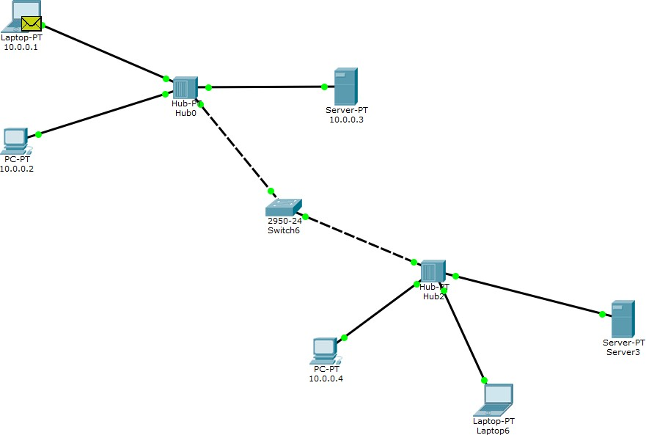

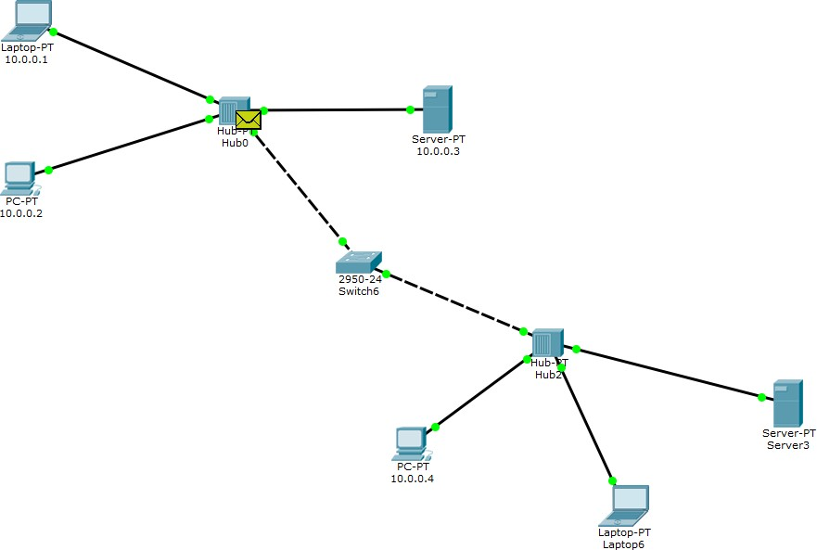

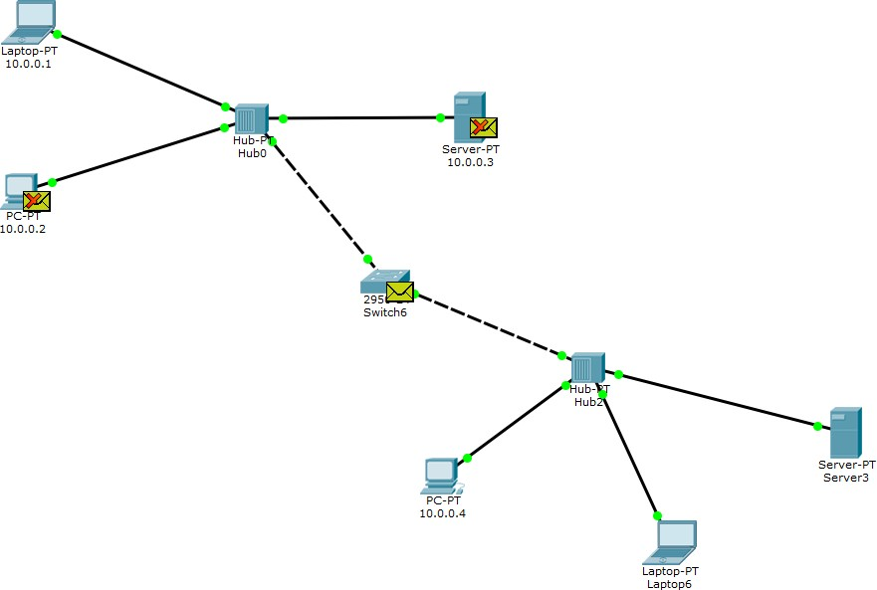

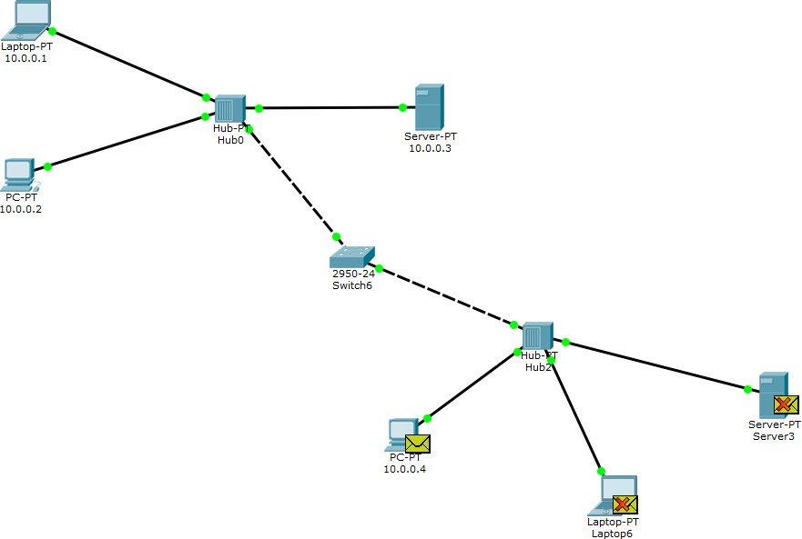

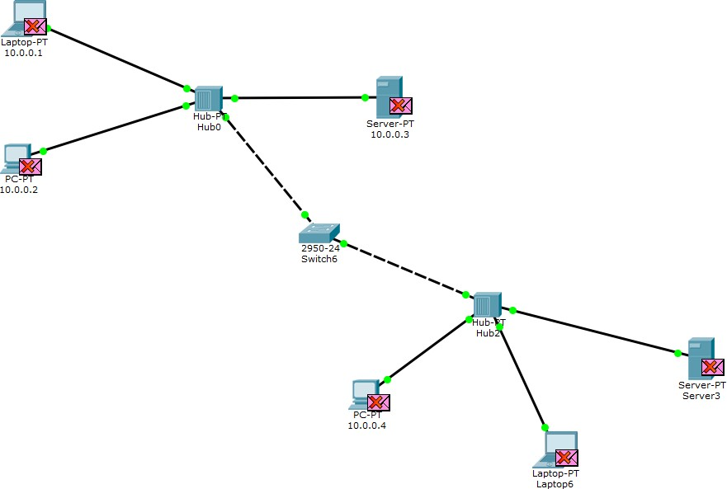

**SWITCH CONNECTION**

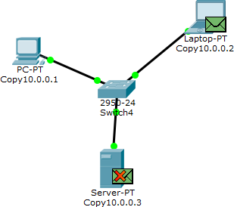

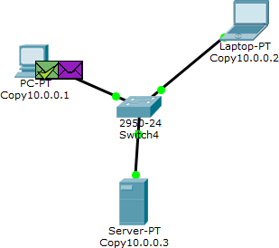

## HUB CONNECTION

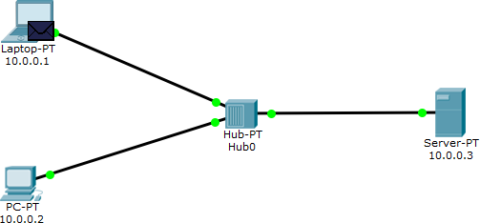

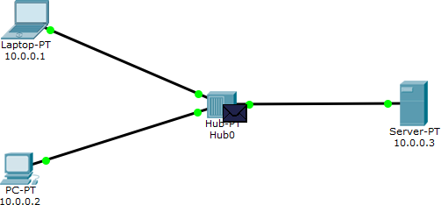

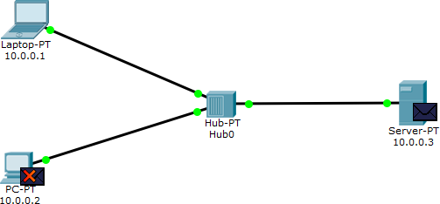

**Lab 2**

Configure IP address to routers in packet tracer. Explore the following messages: ping responses, destination unreachable, request timed out, reply

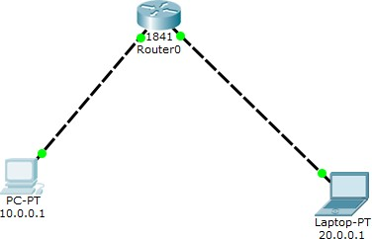

Packet loss:

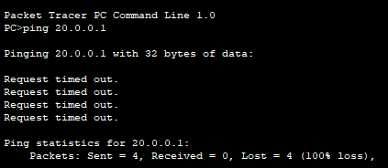

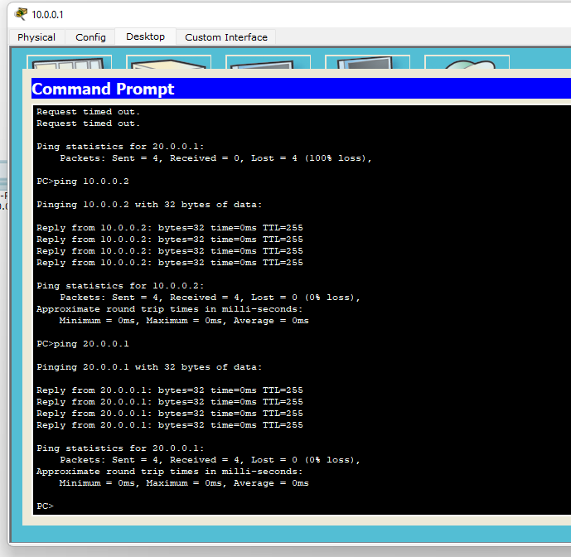

Successful Connection

Multiple Router Connection:

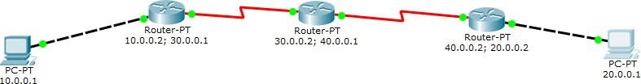

Request time out:

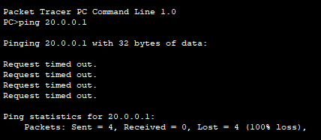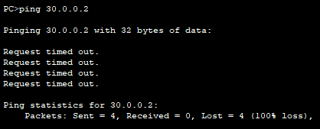

Destination Host Unreachable:

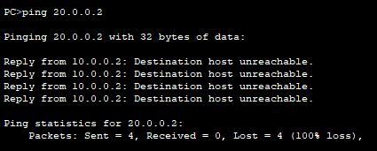

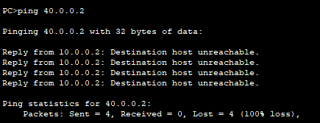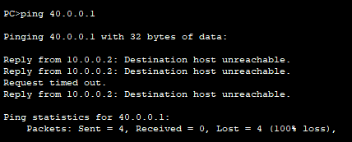

Sent:

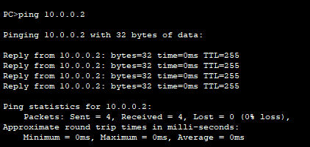

## Lab 3

**Question:**

Configure default route, static route to the Router

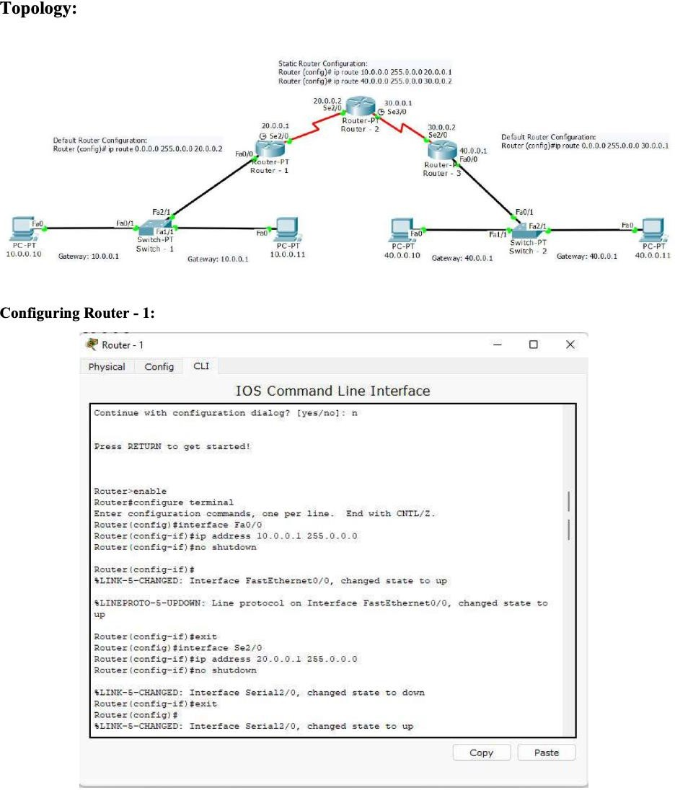

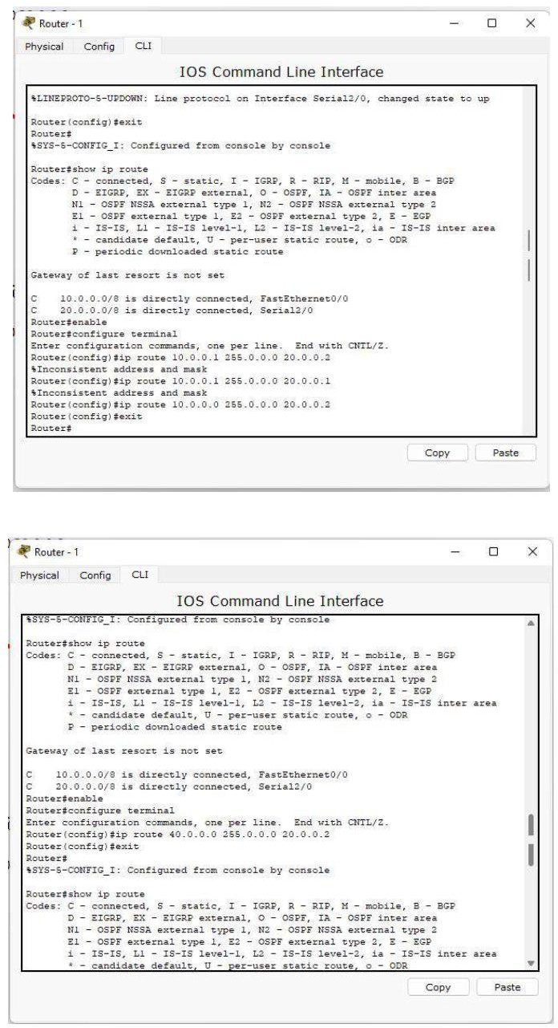

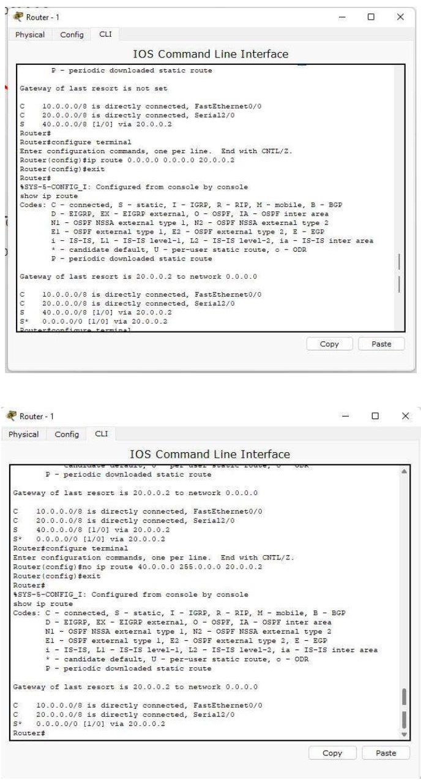

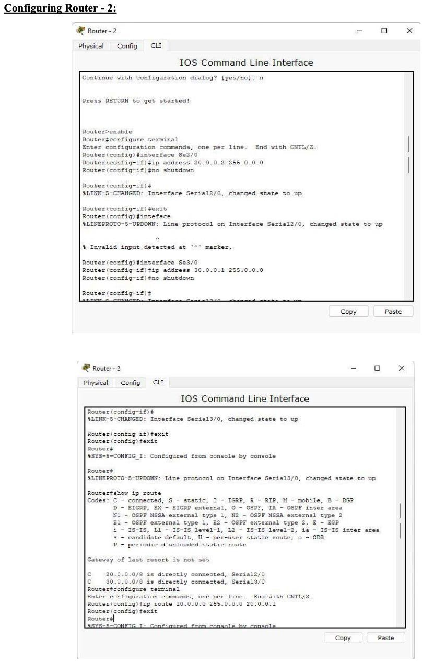

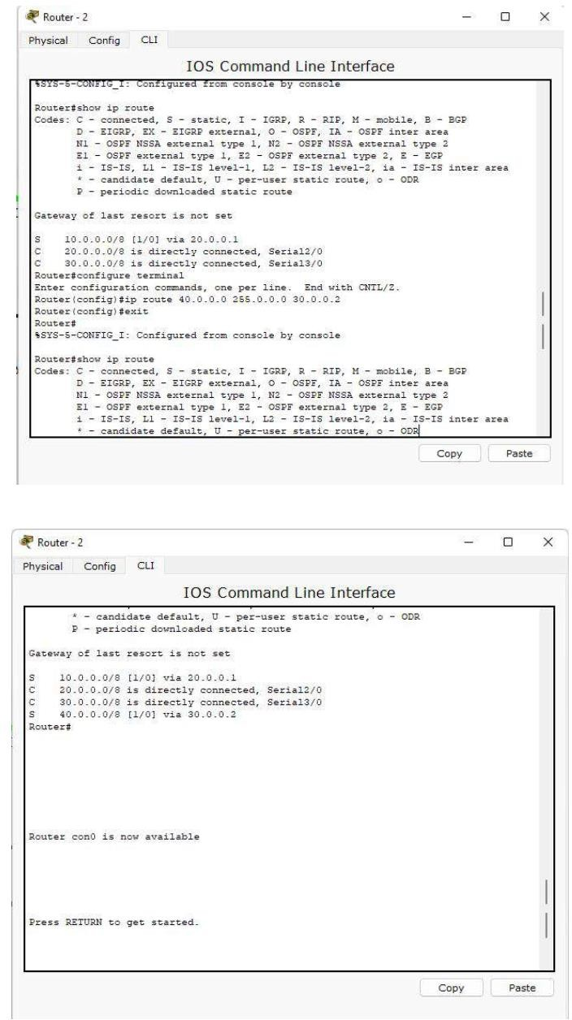

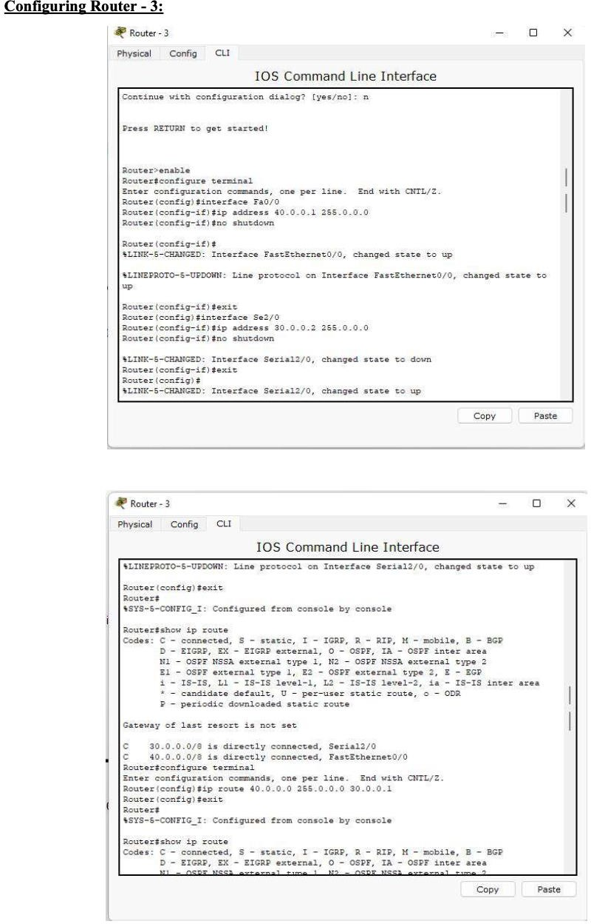

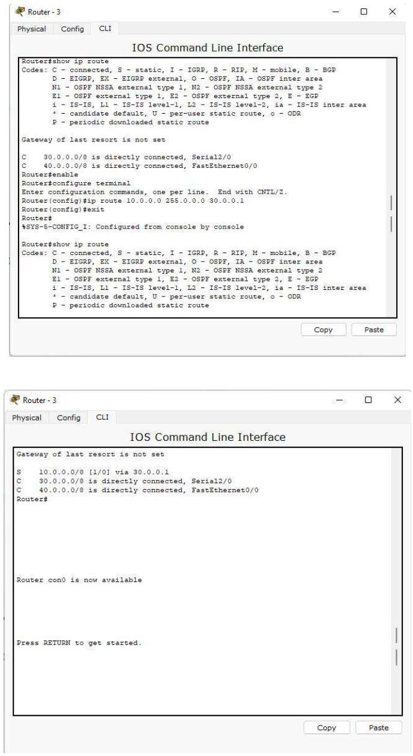

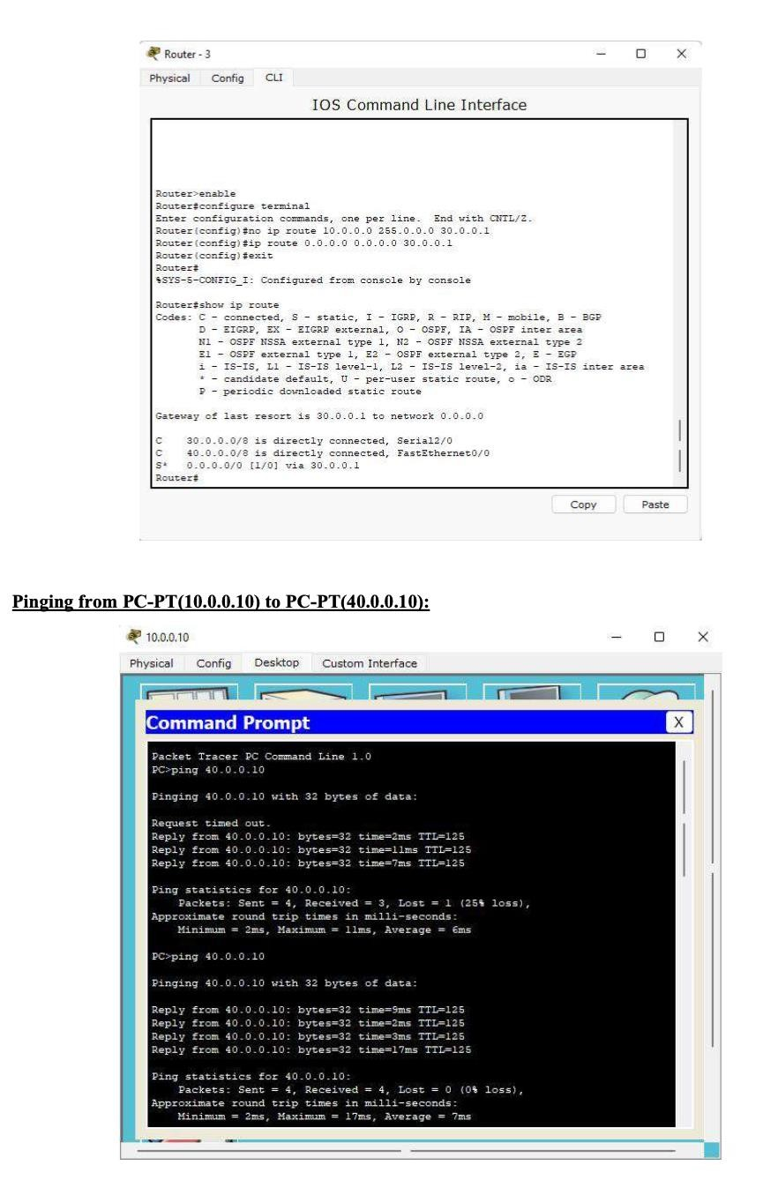

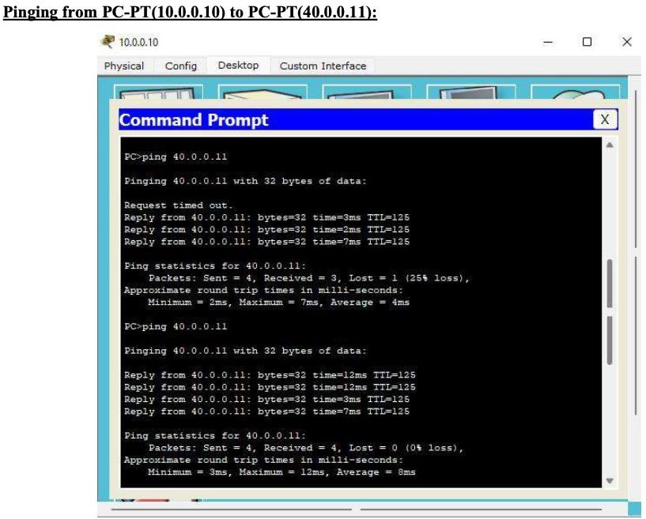

## Lab 4

Configure DHCP within a LAN and outside LAN. ,

DHCP WITHIN LAN

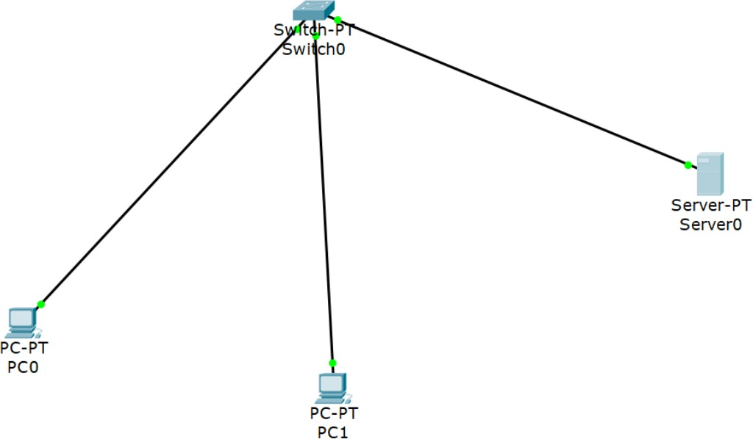

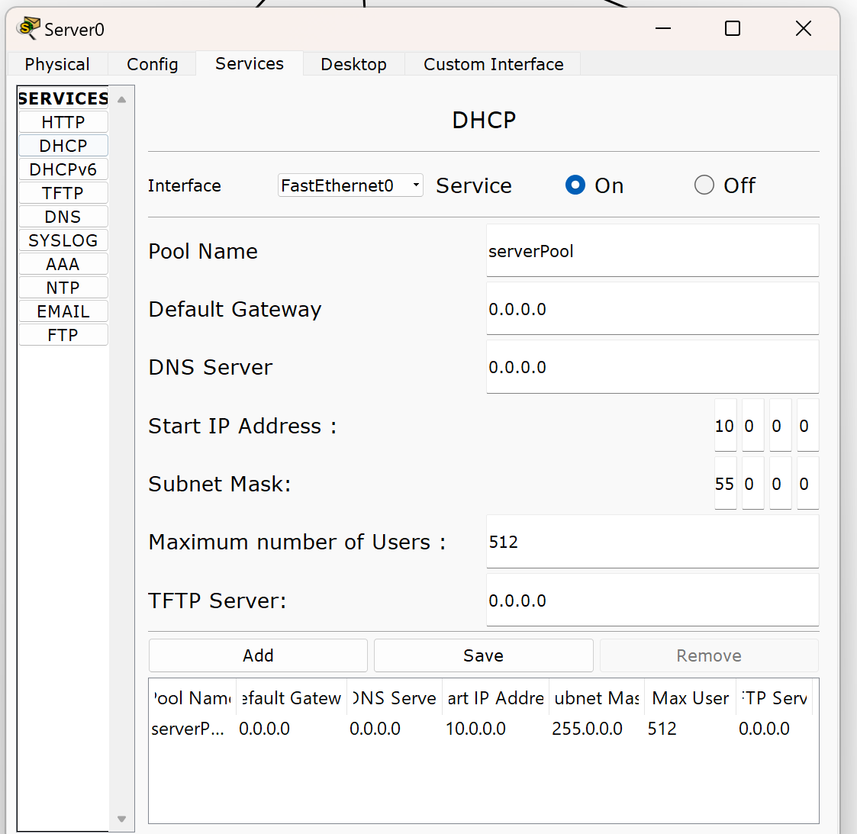

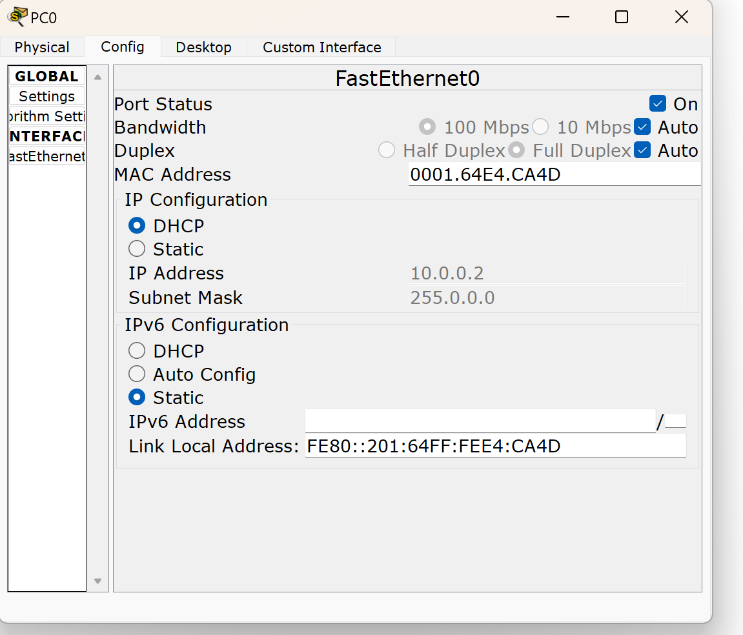

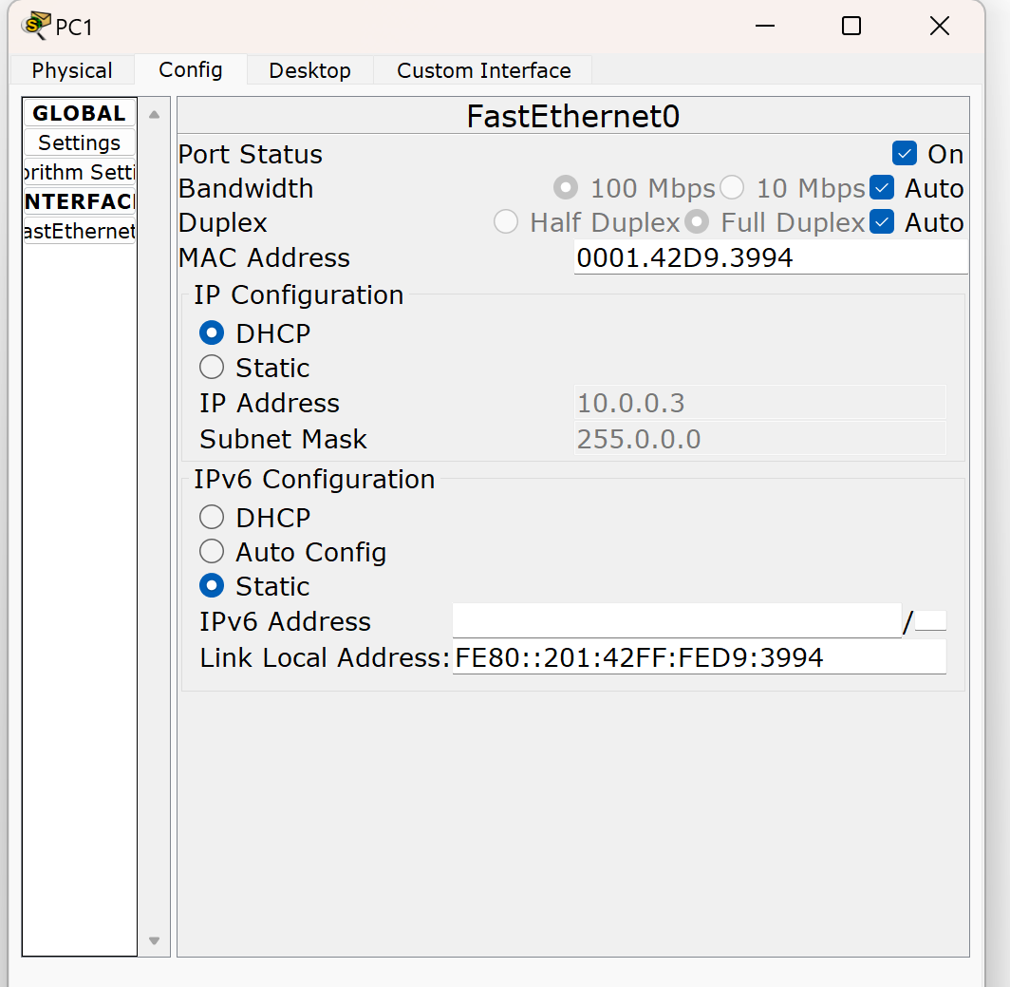

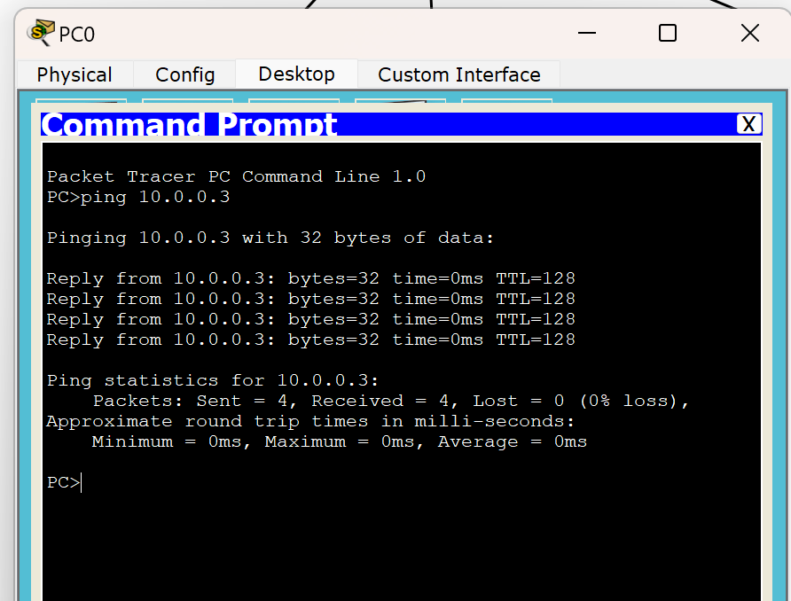

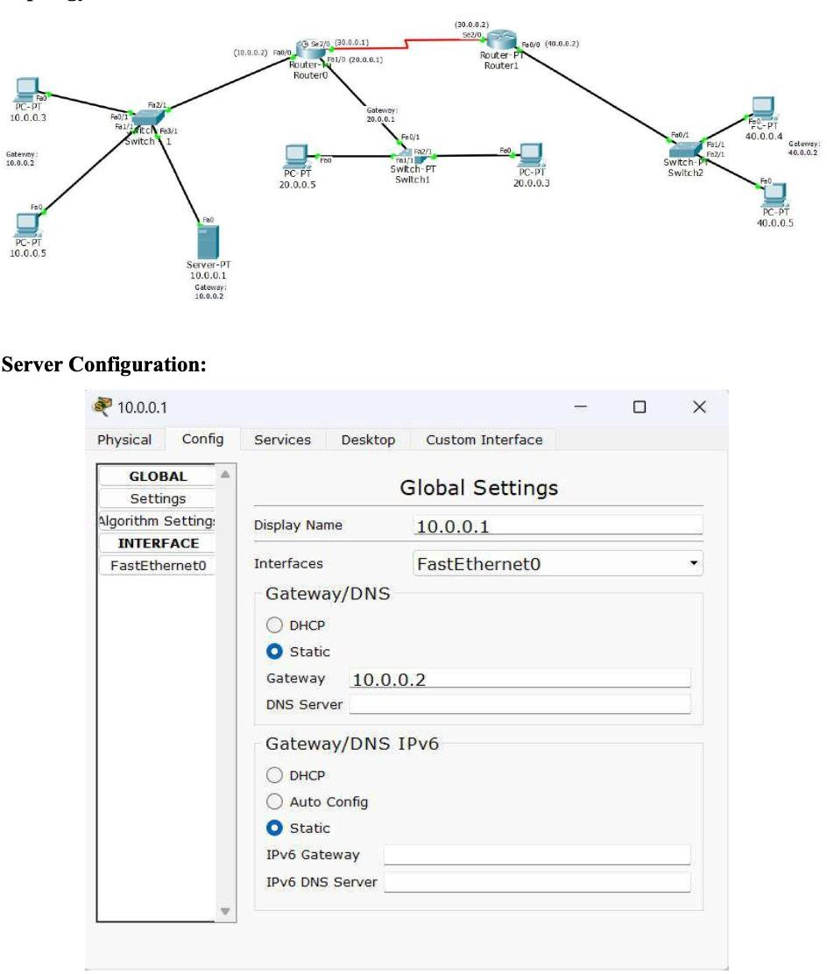

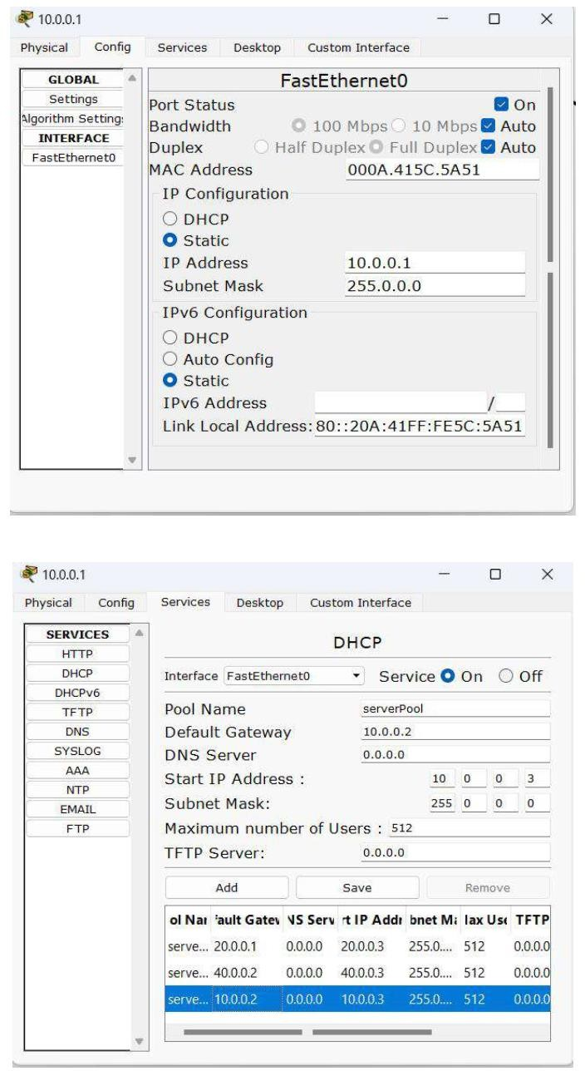

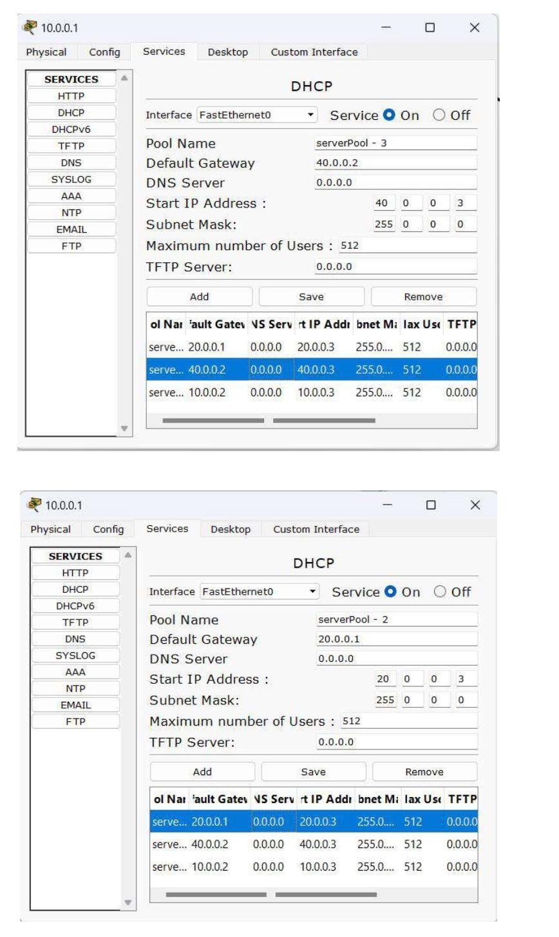

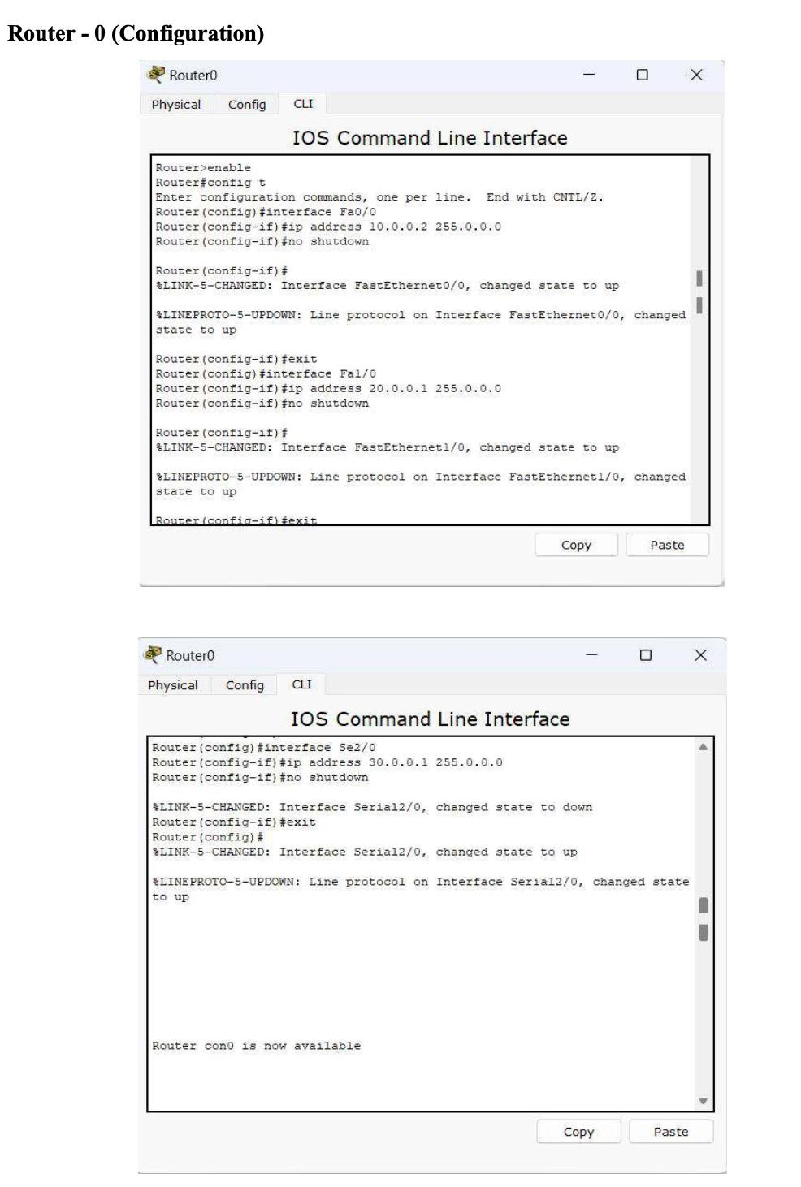

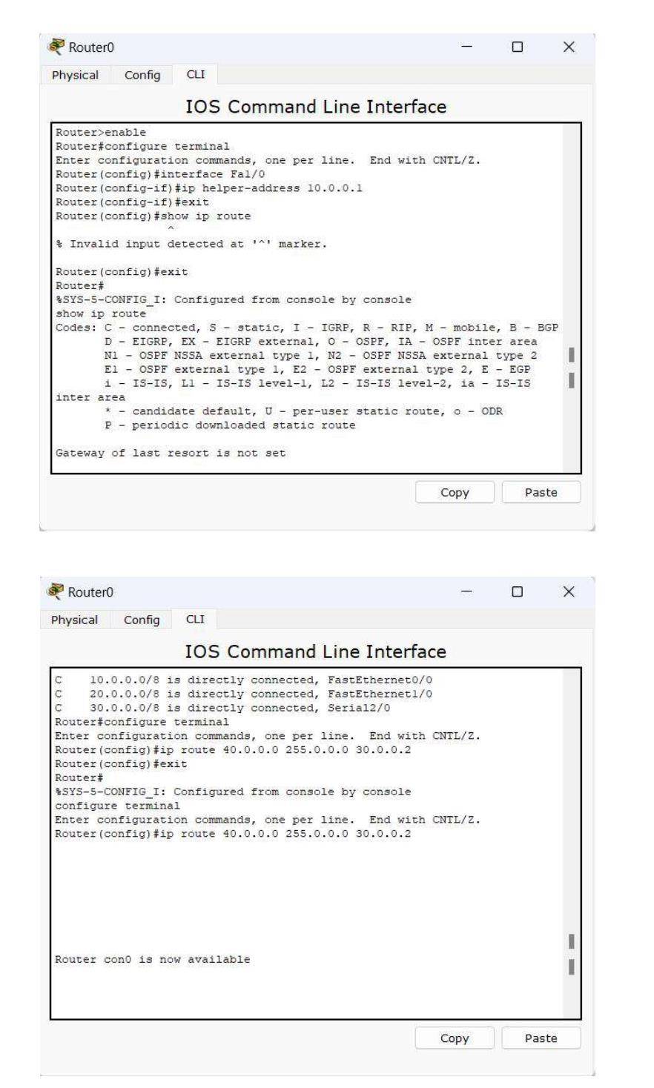

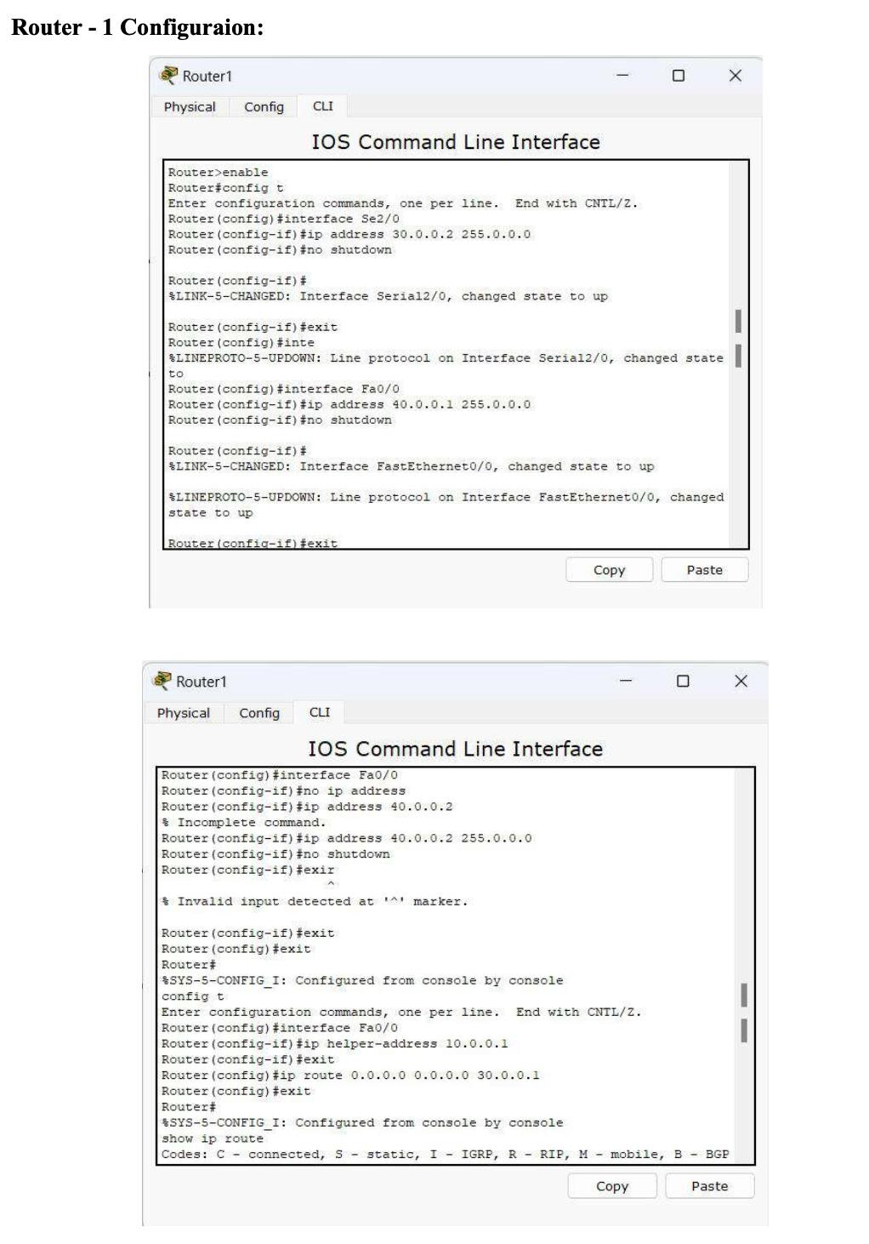

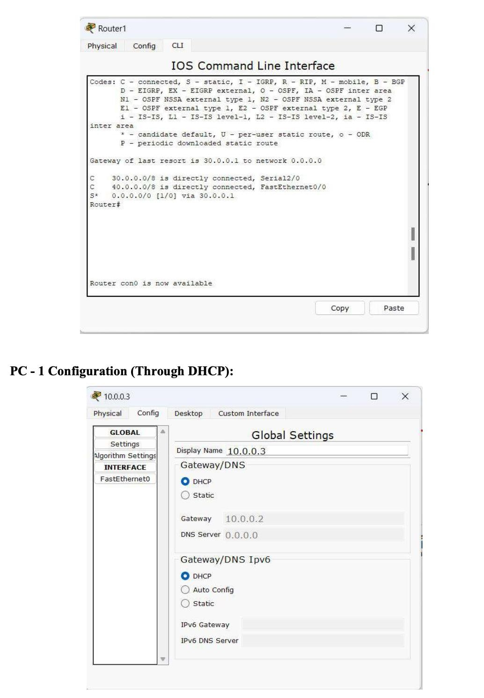

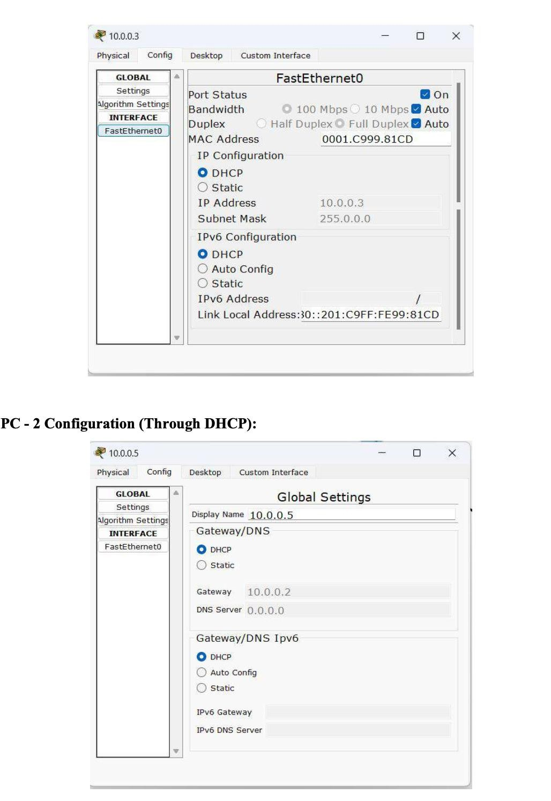

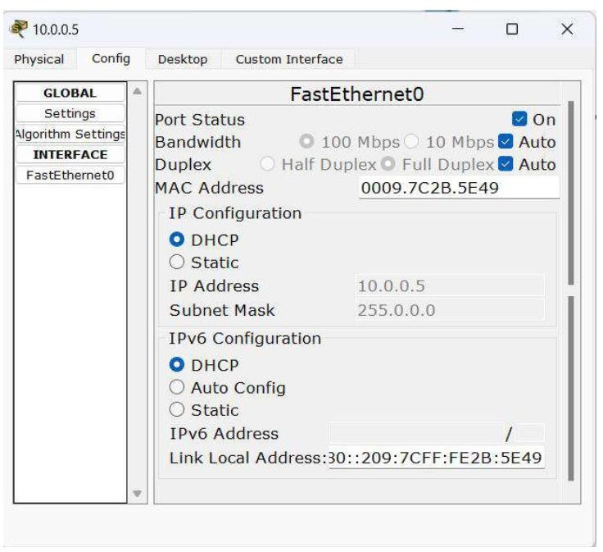

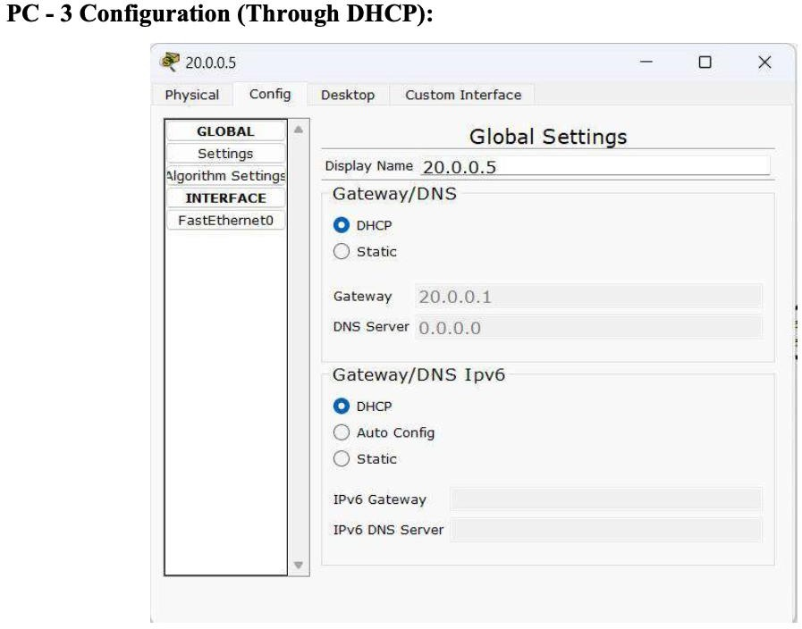

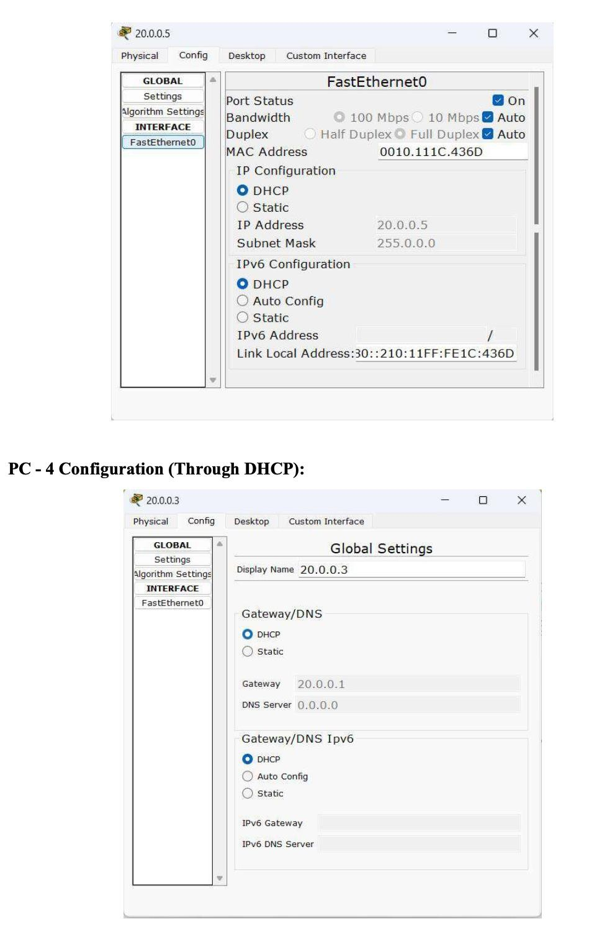

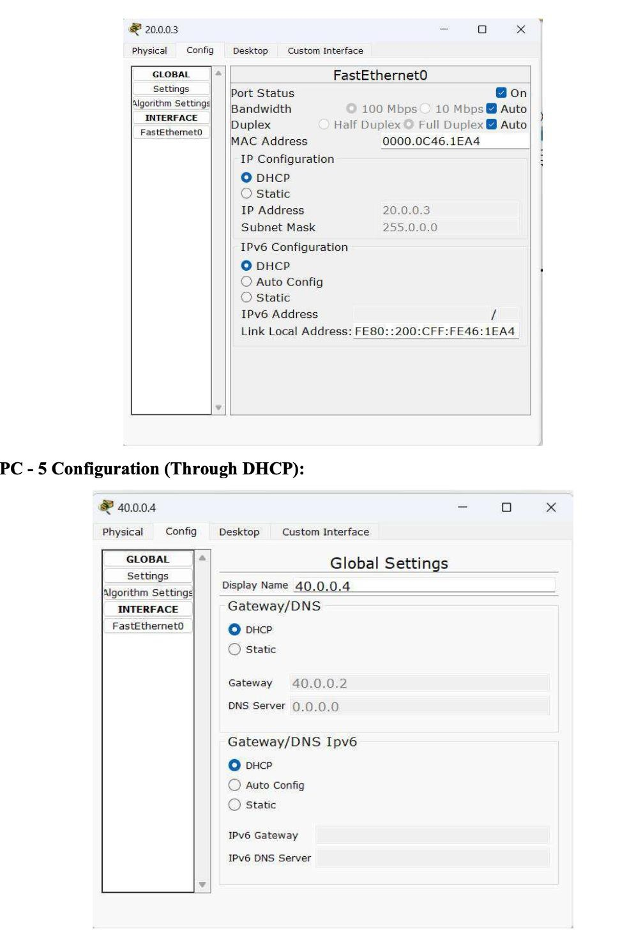

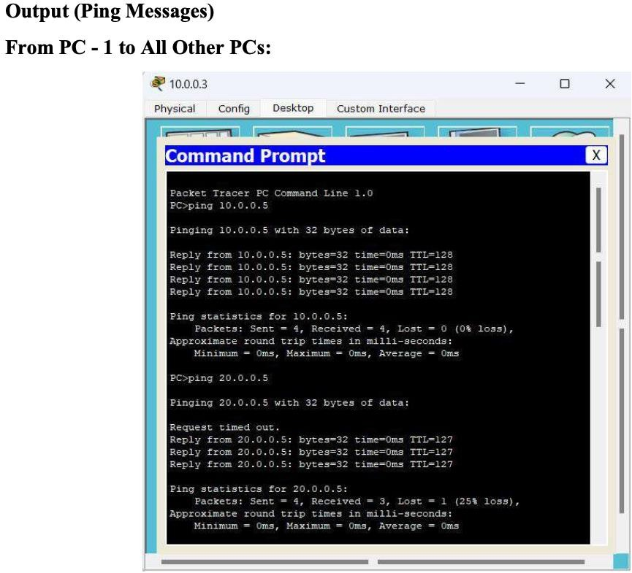

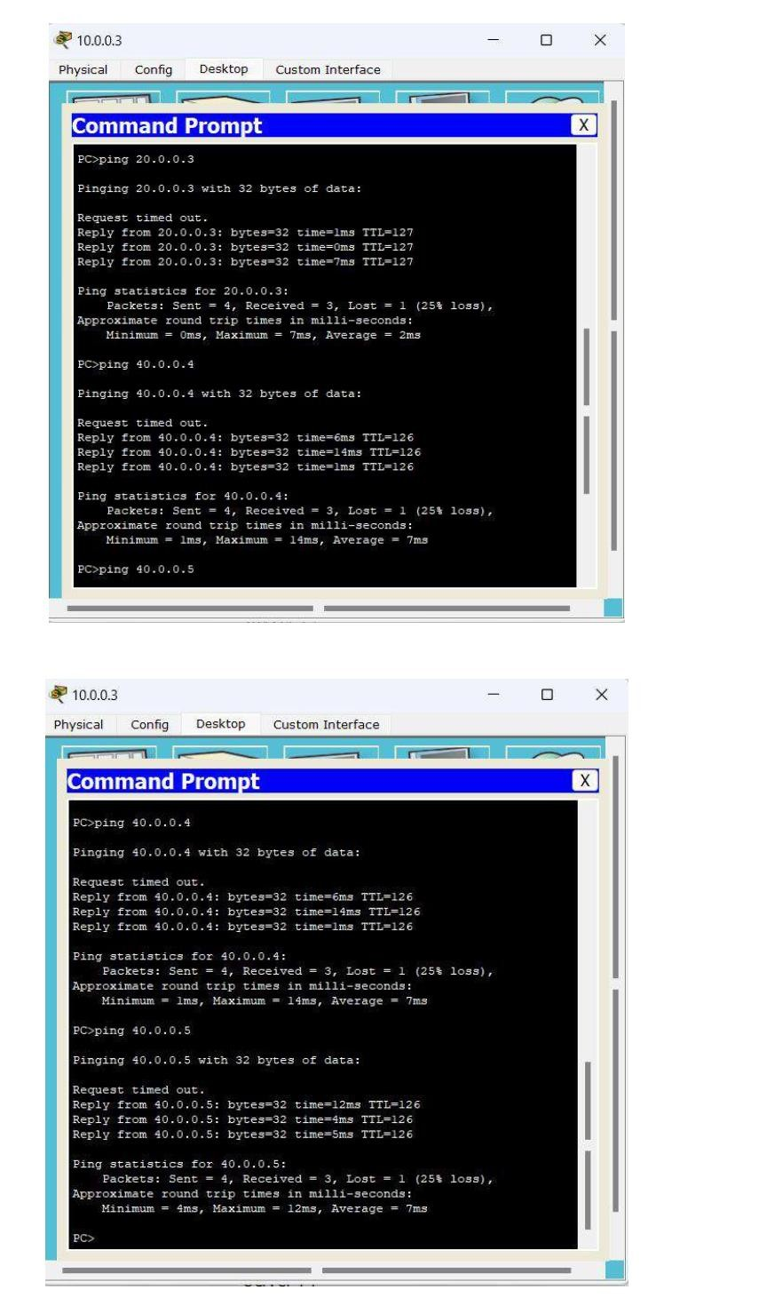

## Lab 5

Configure RIP routing Protocol in Routers

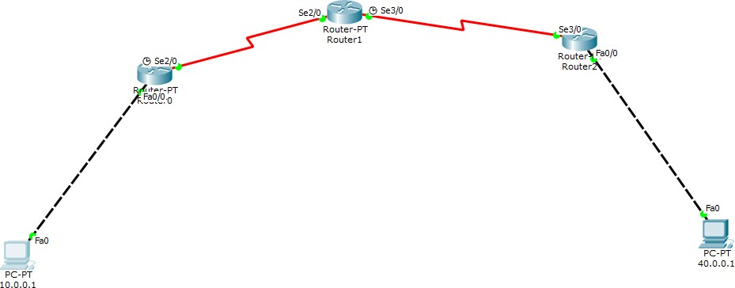

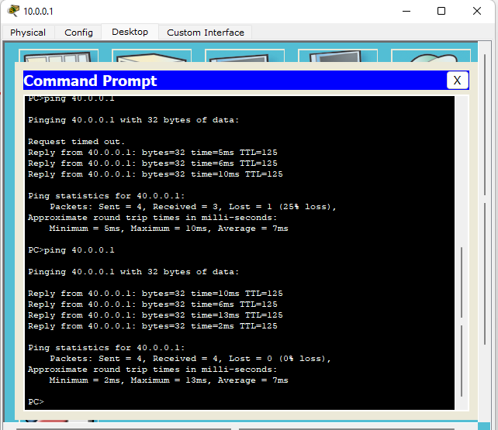

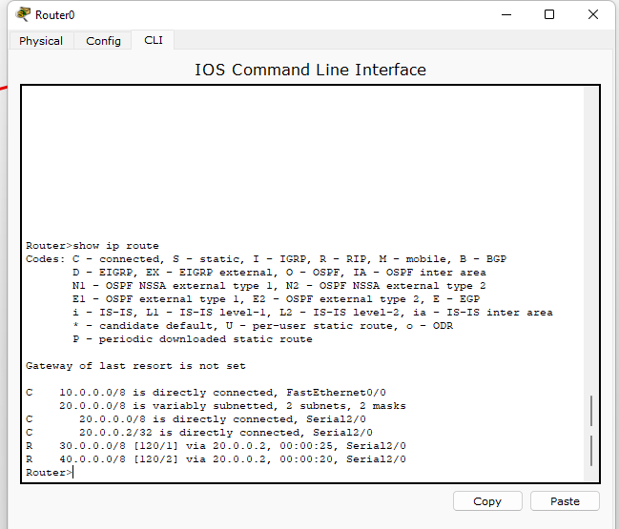

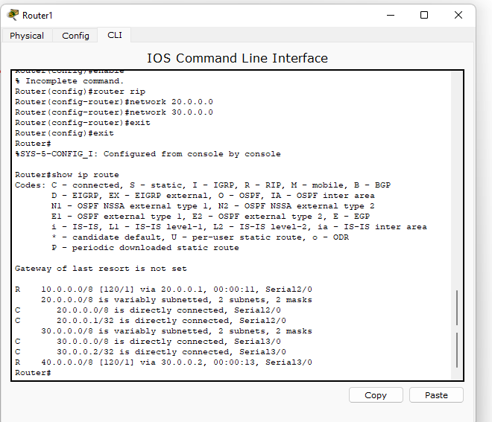

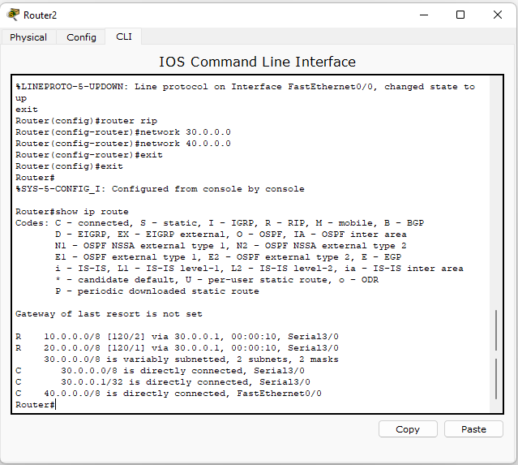

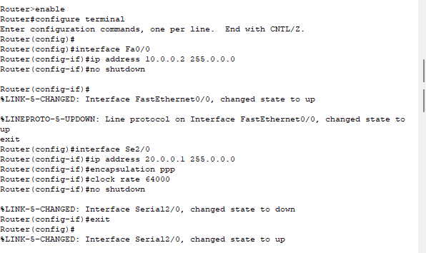

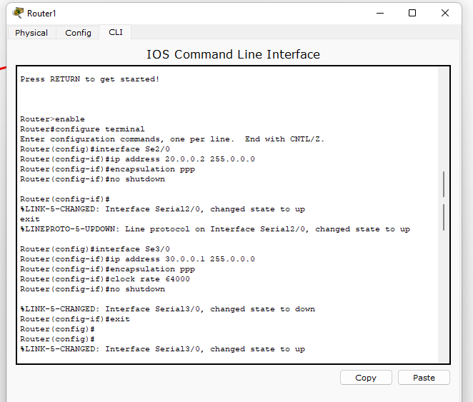

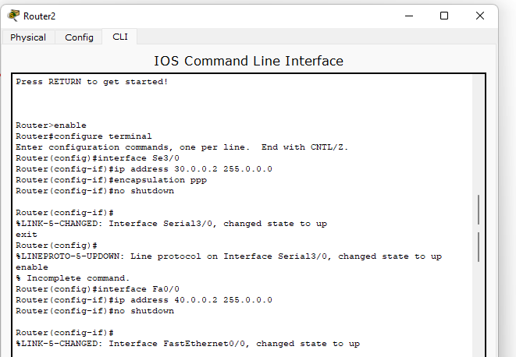

RIP:

For router0

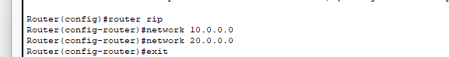

For router1

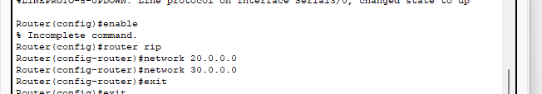

For router2

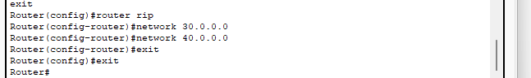

## Lab 5

Configure OSPF routing protocol

Topology:

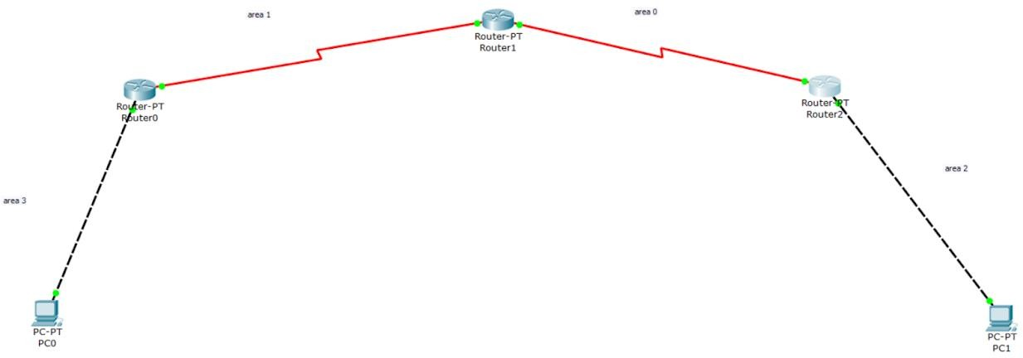

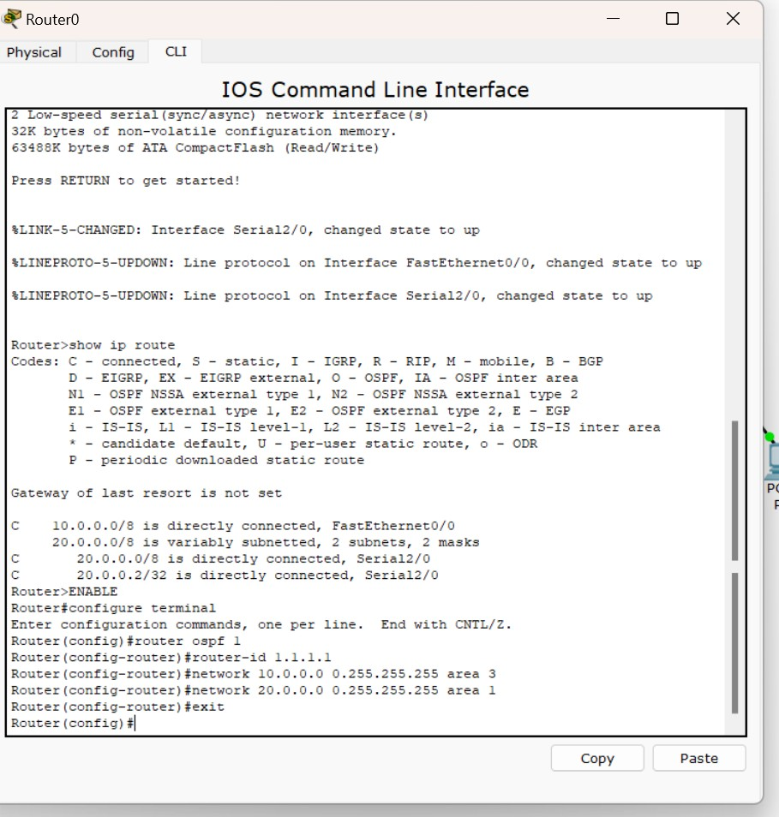

Router 1:

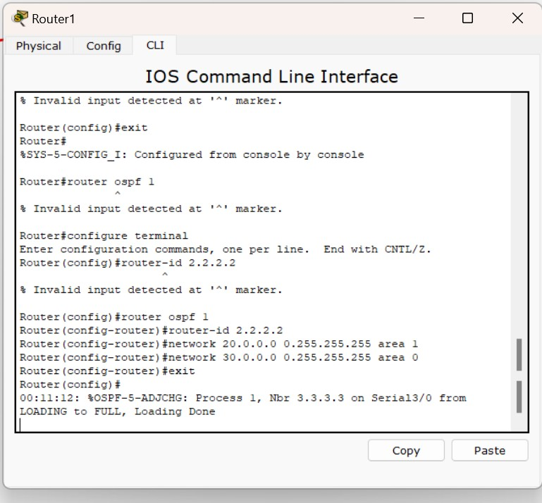

Router 2:

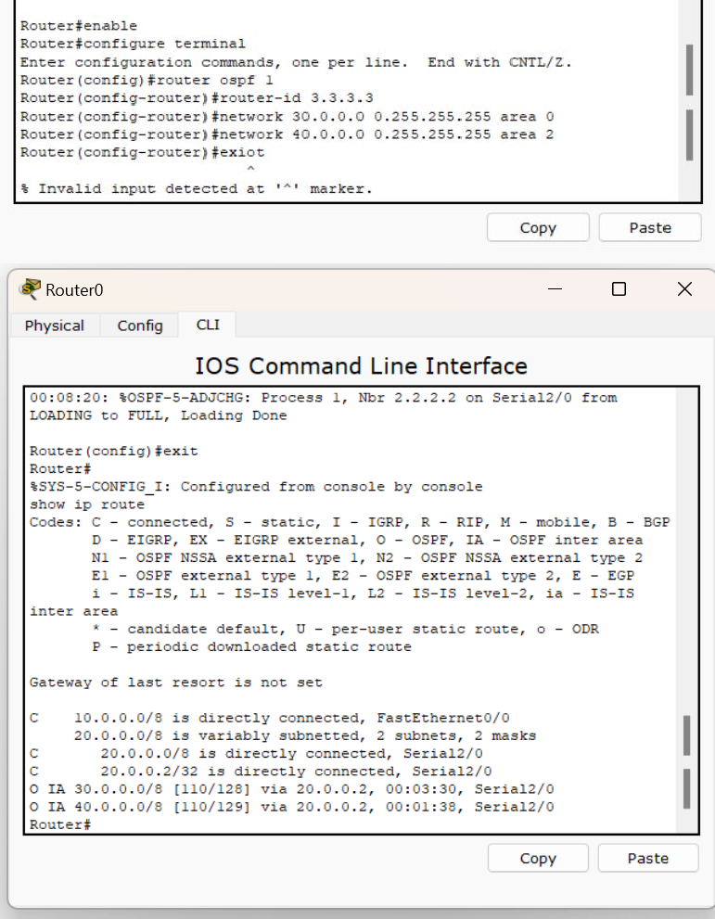

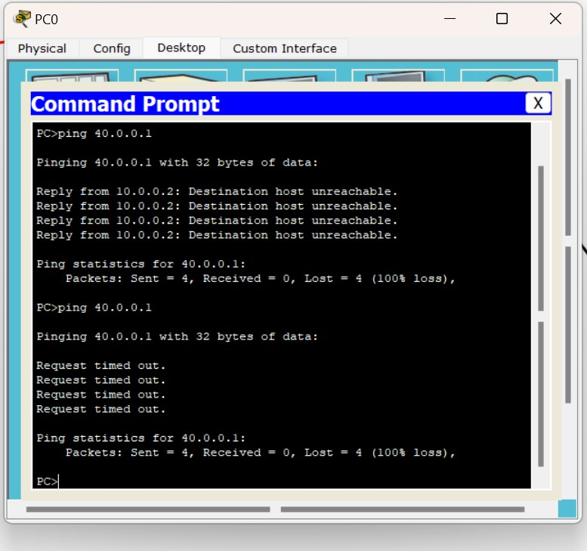

Loopback Router 0:

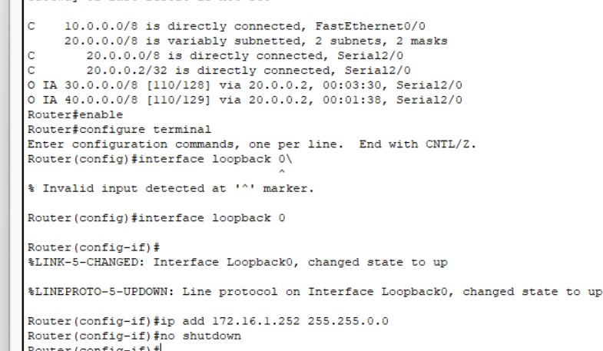

Router 1:

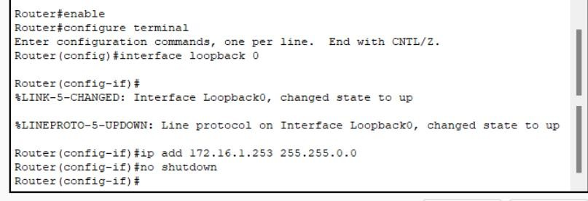

Router 2:

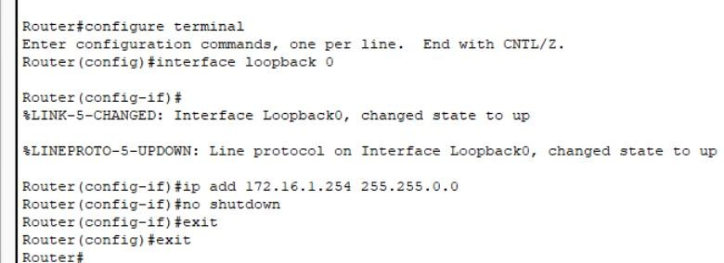

Show ip route after interface loopback for router 2

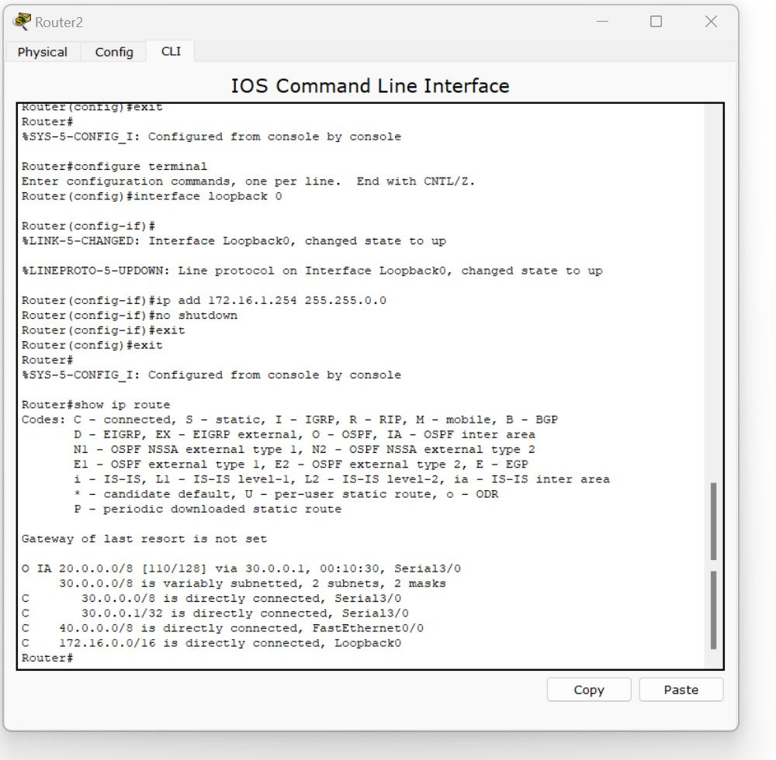

We notice that router 3 does not know about area 3(there is on 10.0.0.0 shown in the above fig)

Virtual link Router 0:

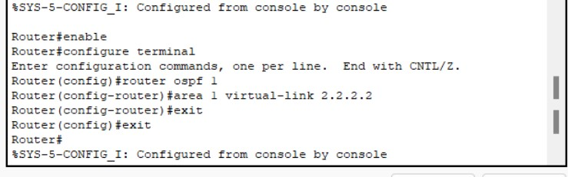

Router 1

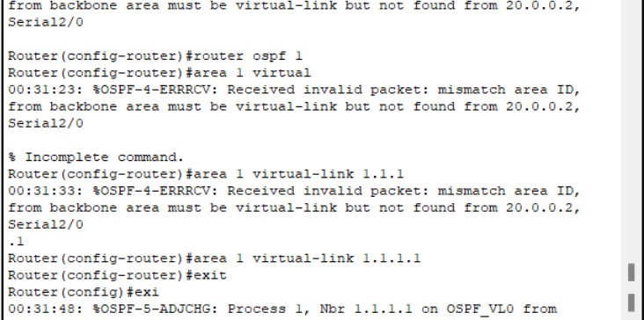

Show ip route command after configuring the virtual link so that router 2 knows that area 3

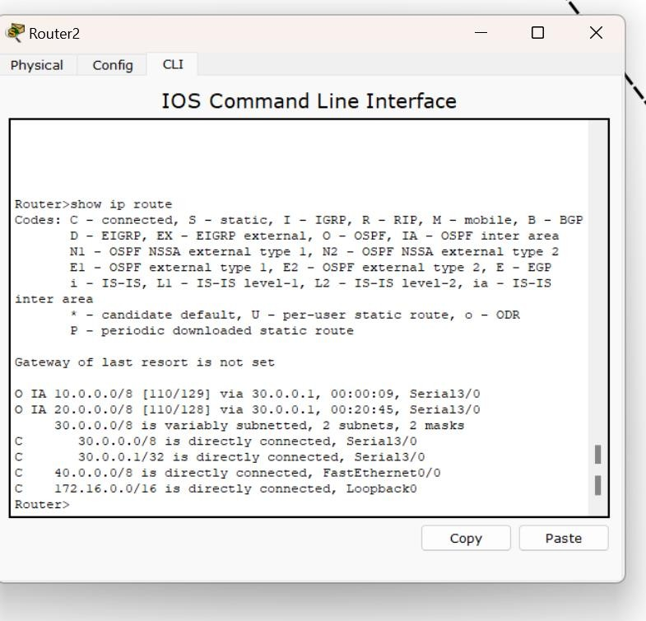

Now we see that the ping command works

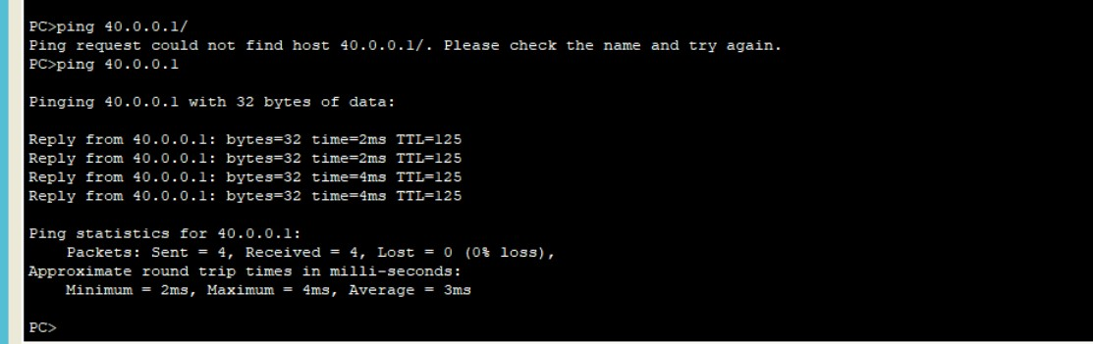

## Lab 7

Demonstrate the TTL/ Life of a Packet

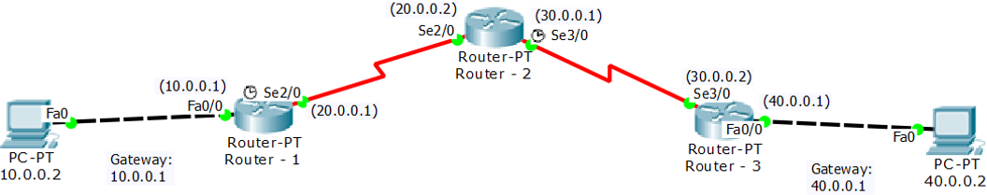

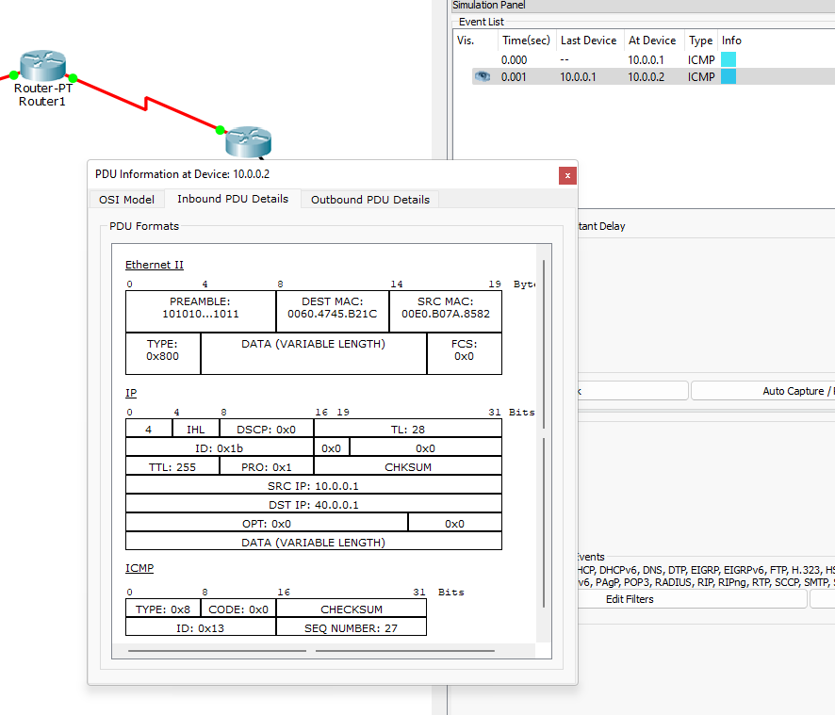

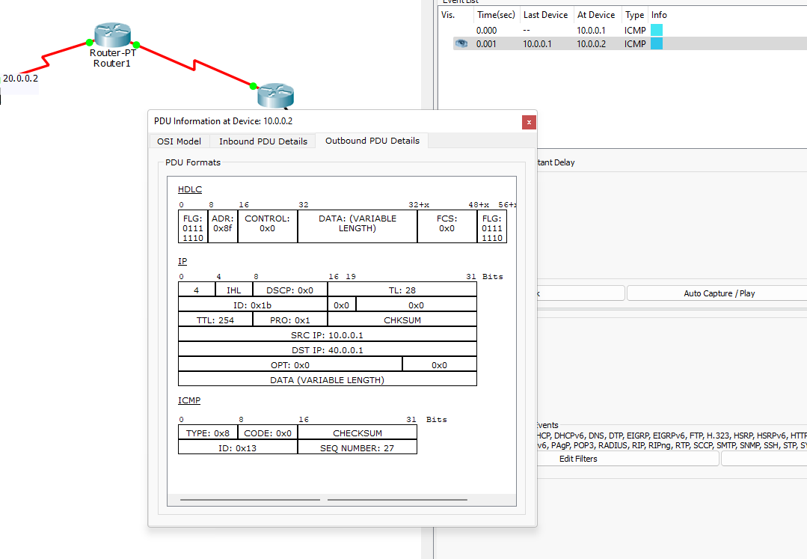

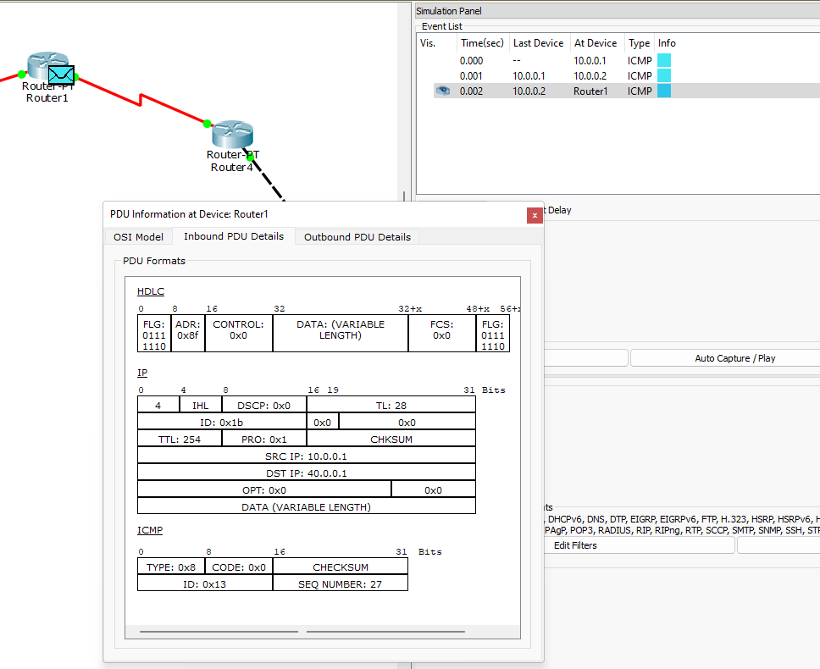

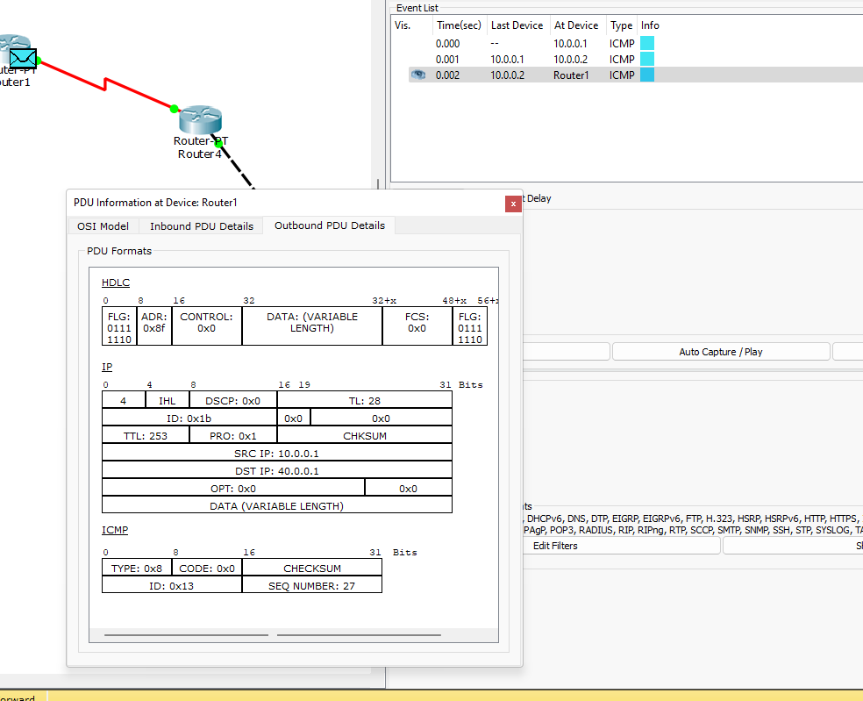

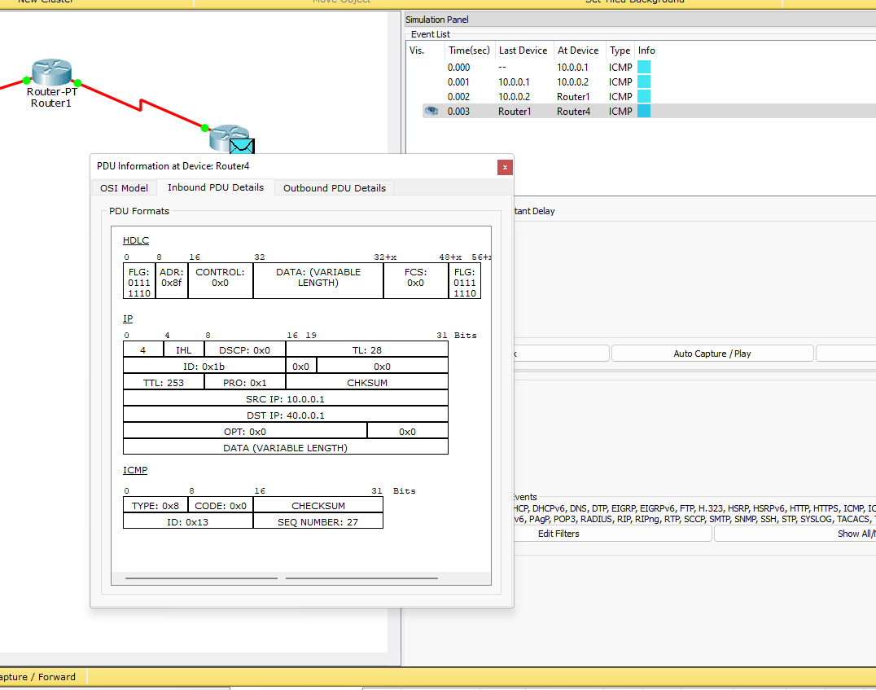

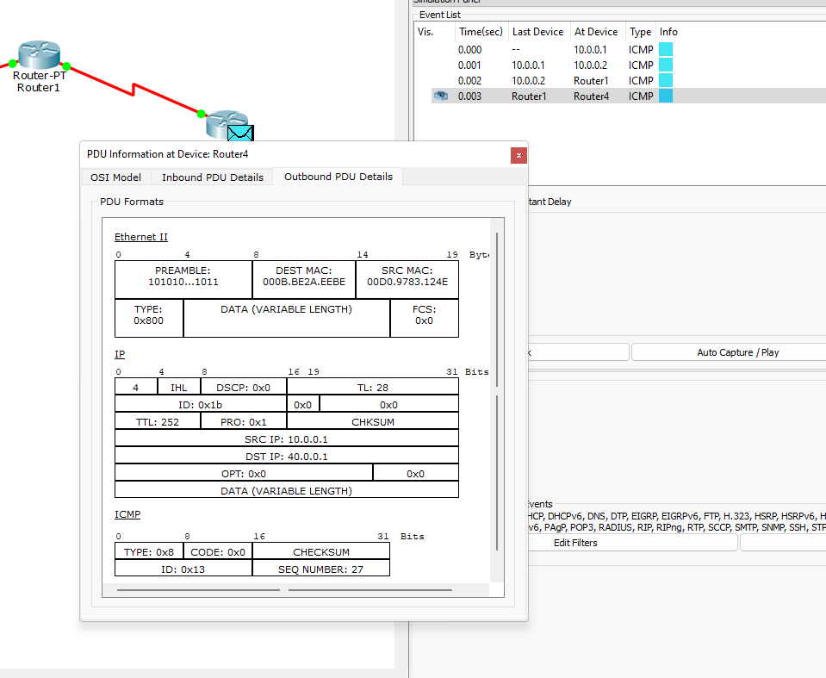

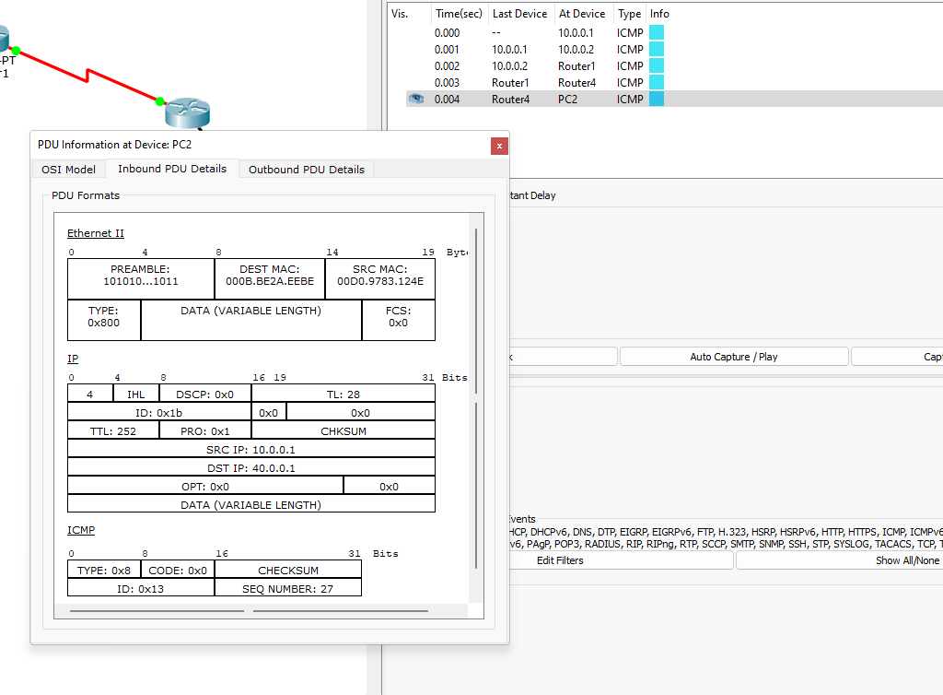

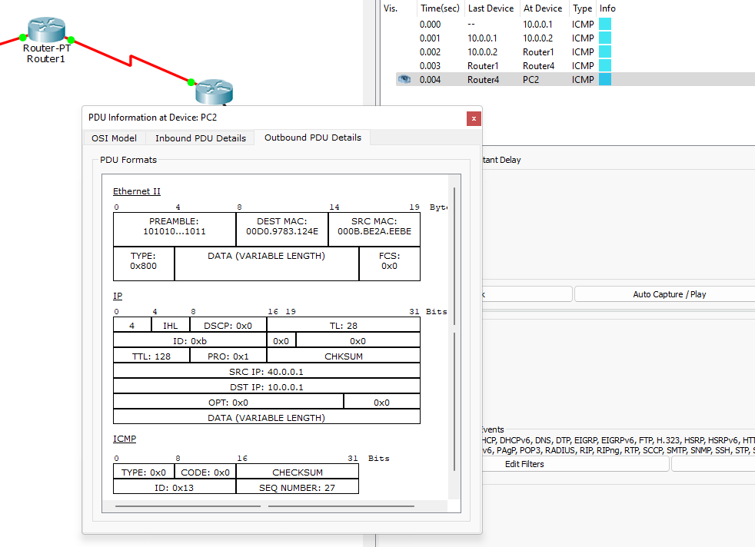

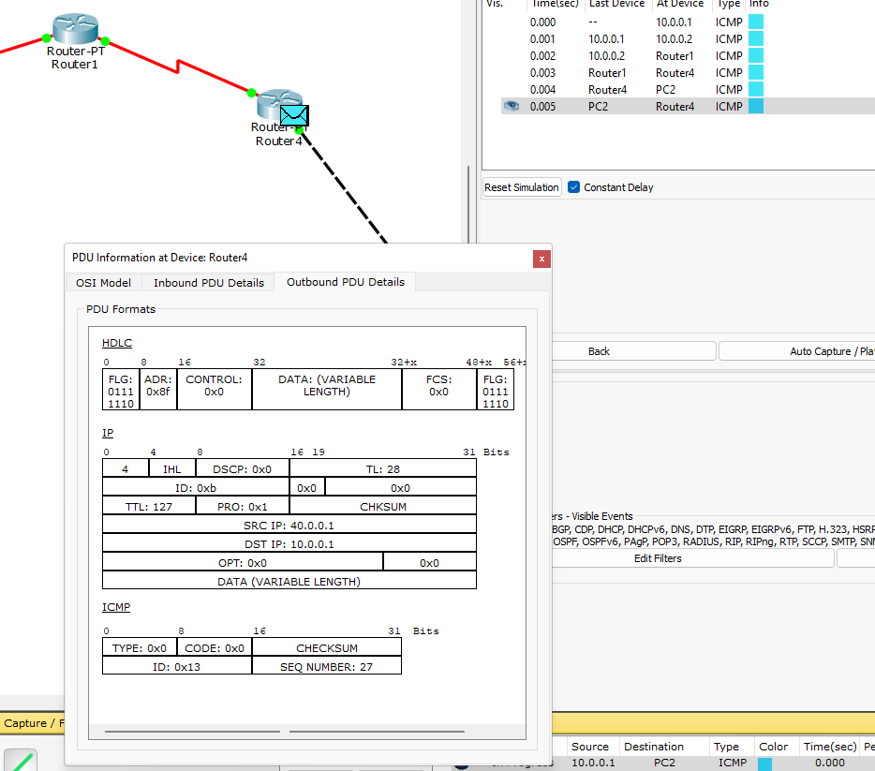

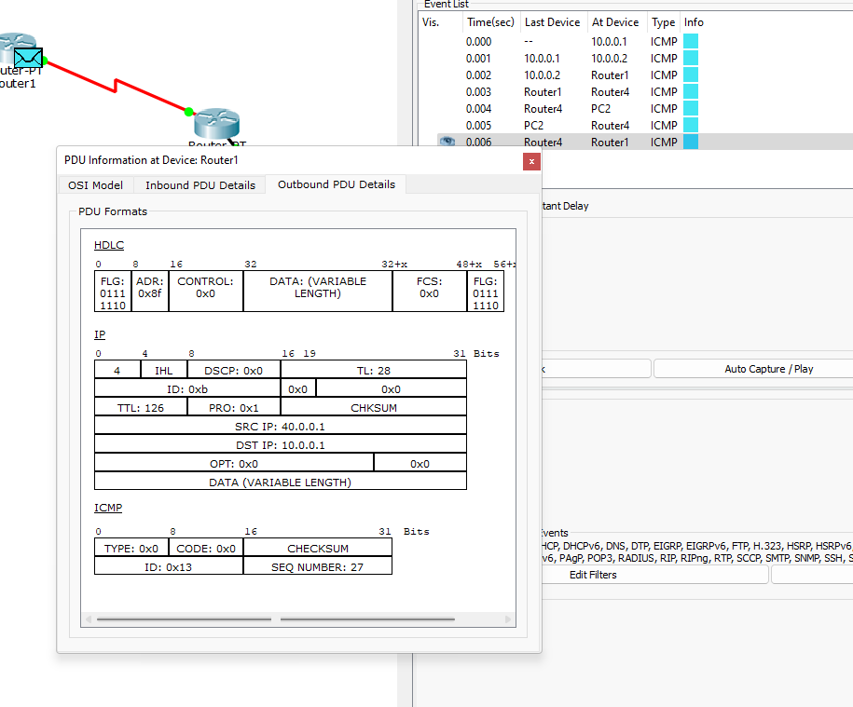

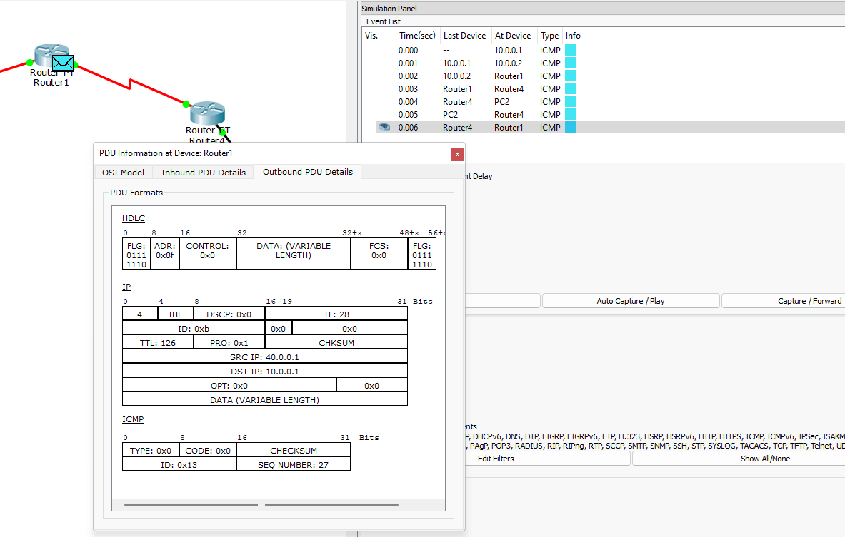

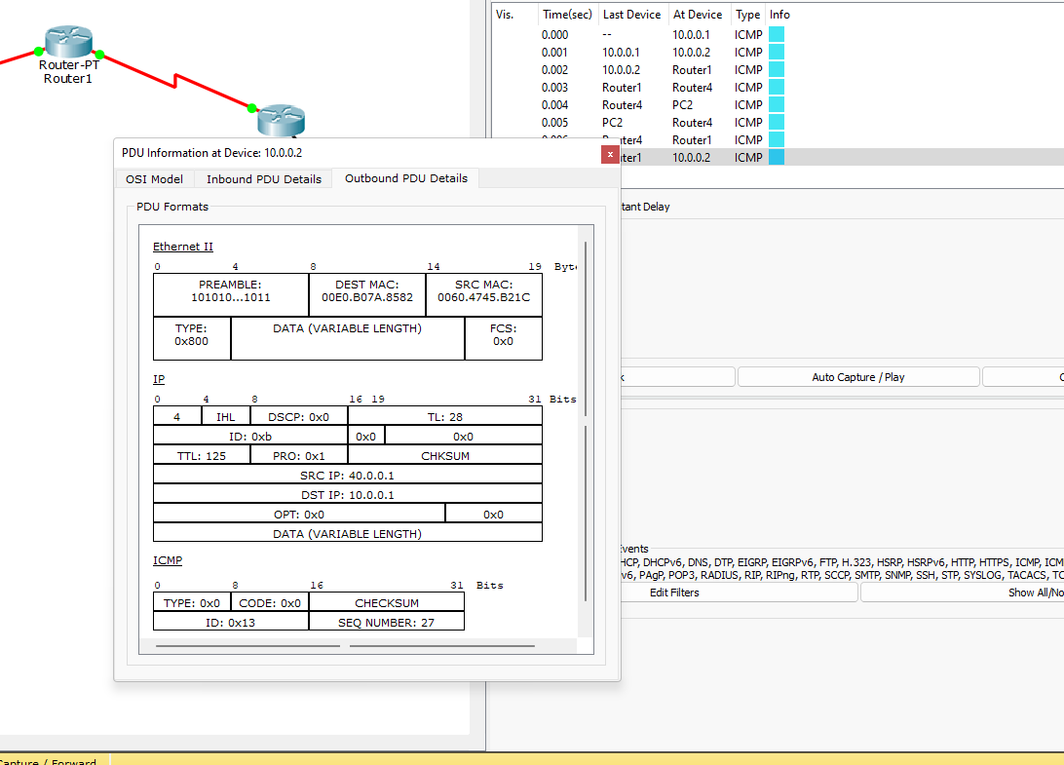

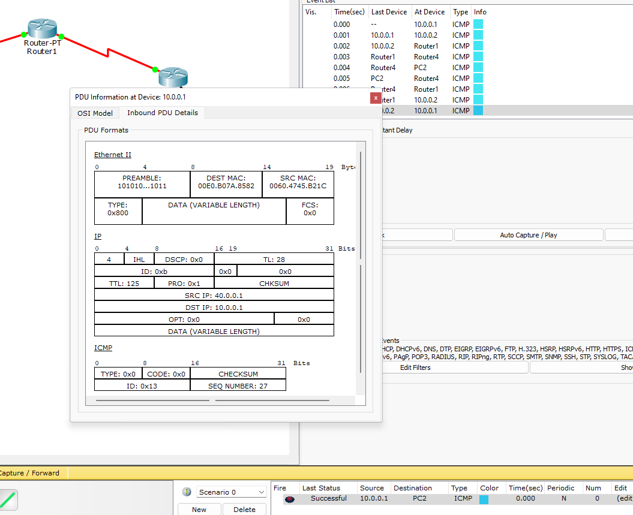

## Lab 8

Configure Web Server, DNS within a LAN.

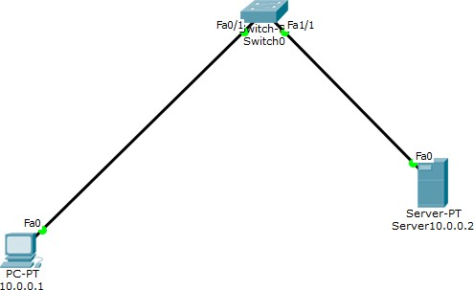

Set the ip address of PC

Then set the ip address of server

Go to DNS -> set the name and ip address of server as the server

Then go to pC and url and you should see the name of the site and it content Go to DNS -> then Index.html and set the Name and usn using html tags

When we access the site through PC , we would see our site with name and usn

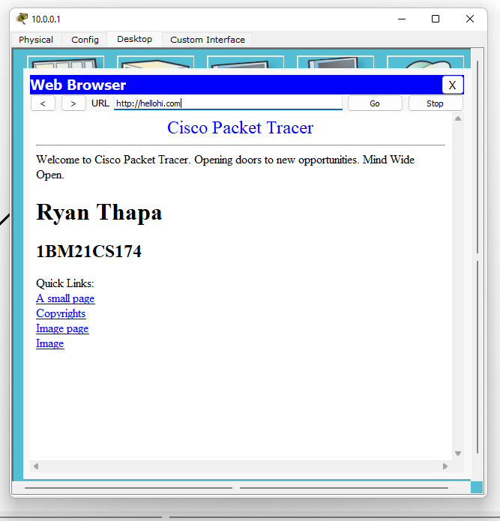

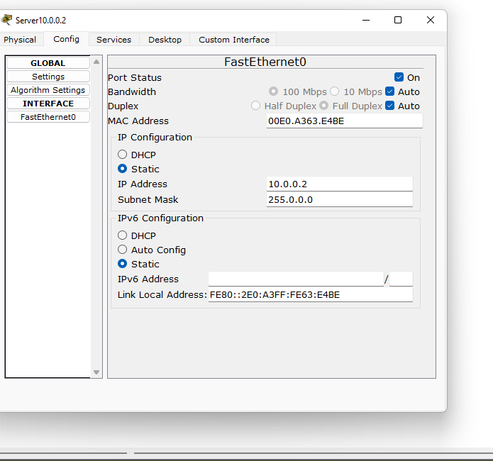

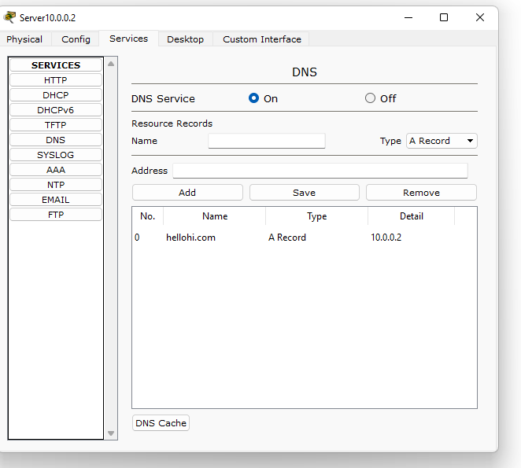

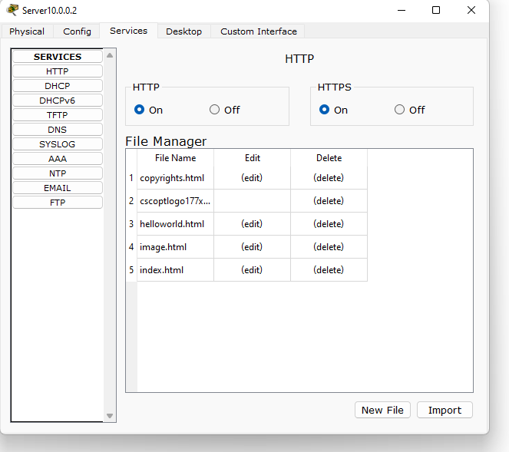

## Lab 9

To construct simple LAN and understand the concept and operation of Address Resolution Protocol (ARP)

# ARP

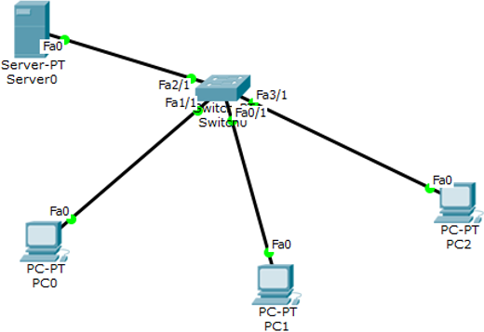

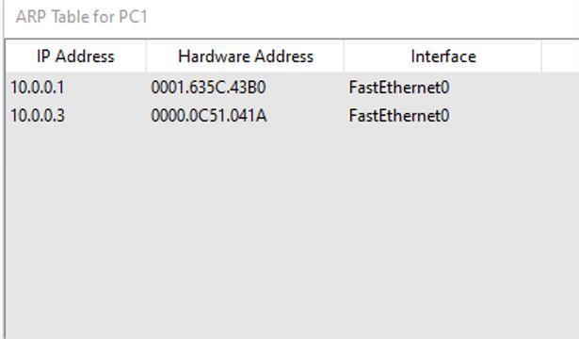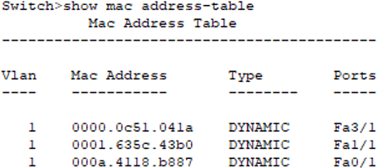

PING PC2 TO PC3

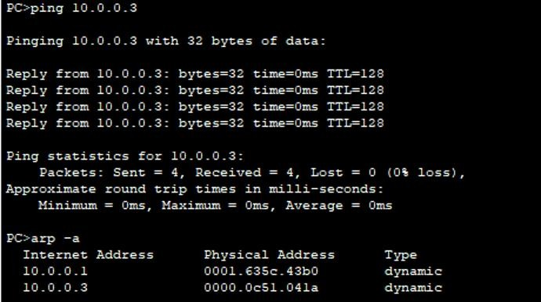

## Lab 10

To understand the operation of TELNET by accessing the router in server room from a PC in IT office

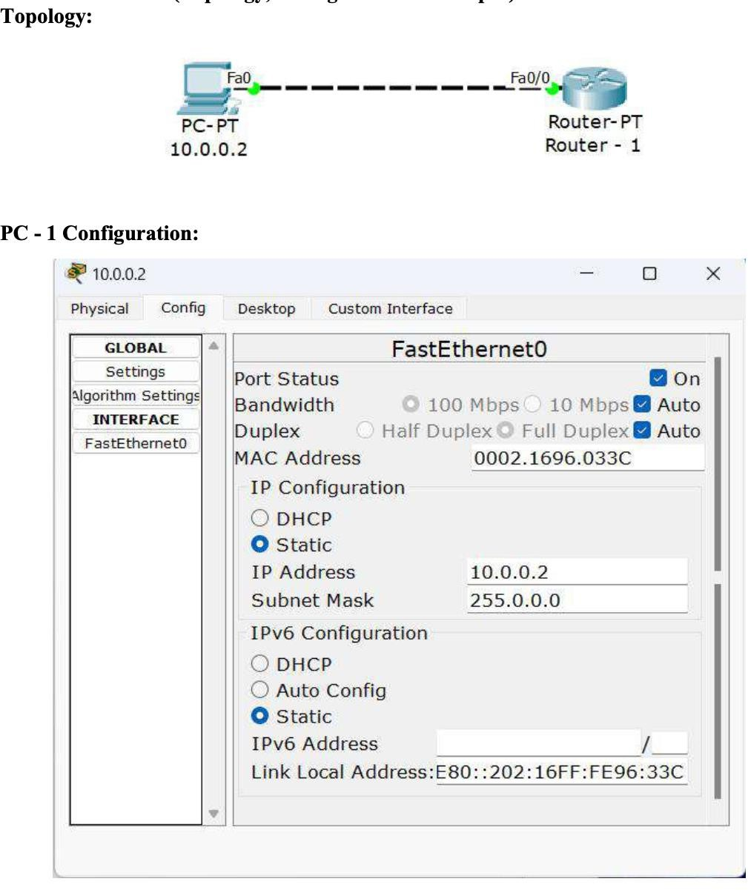

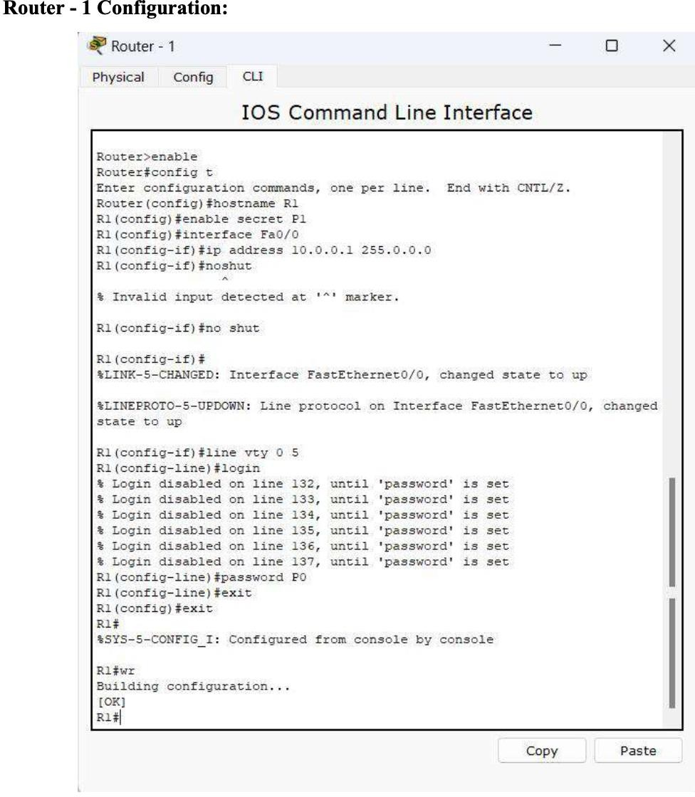

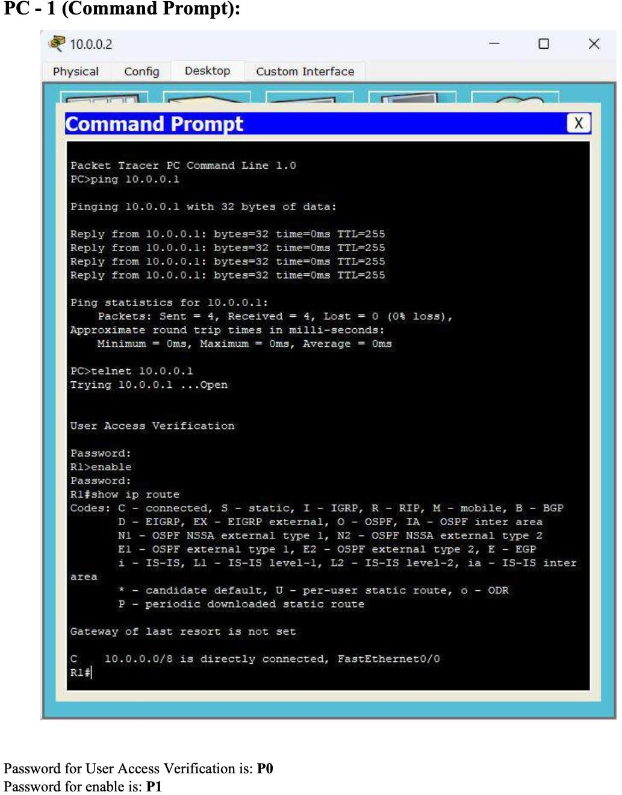

## Lab 11

To construct a VLAN and make the PC’s communicate among a VLAN

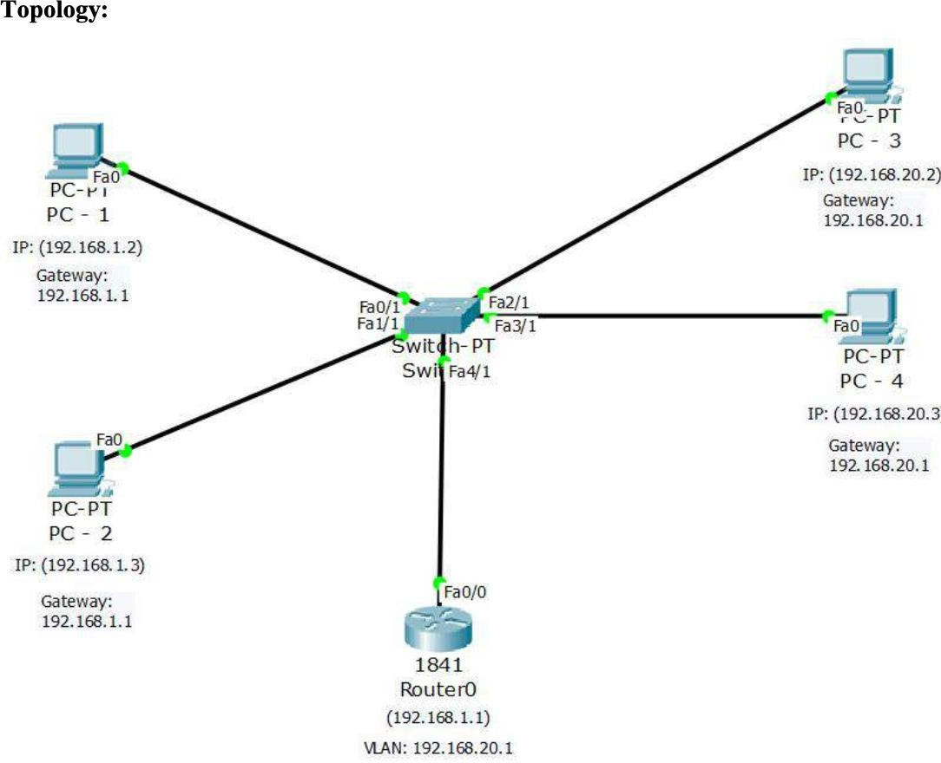

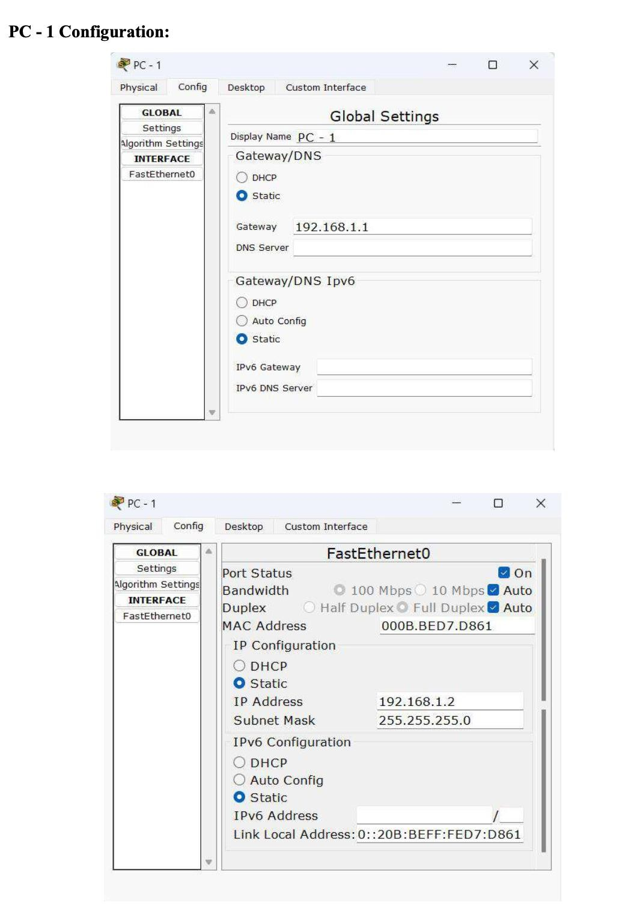

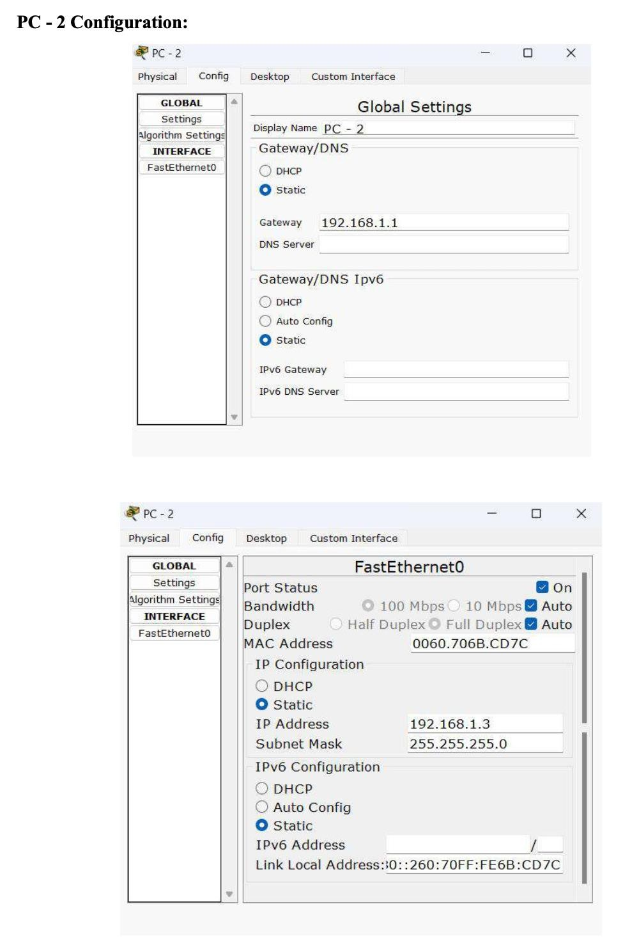

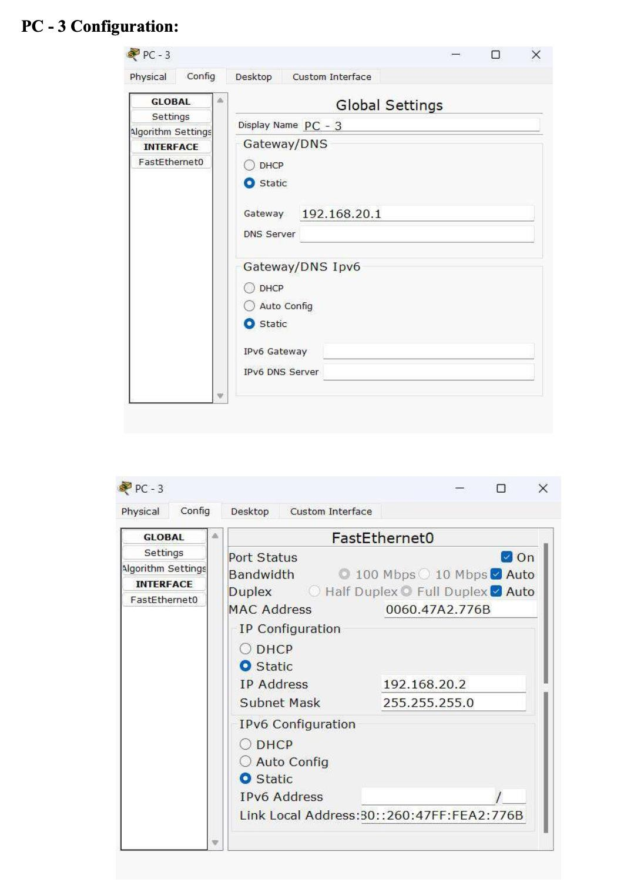

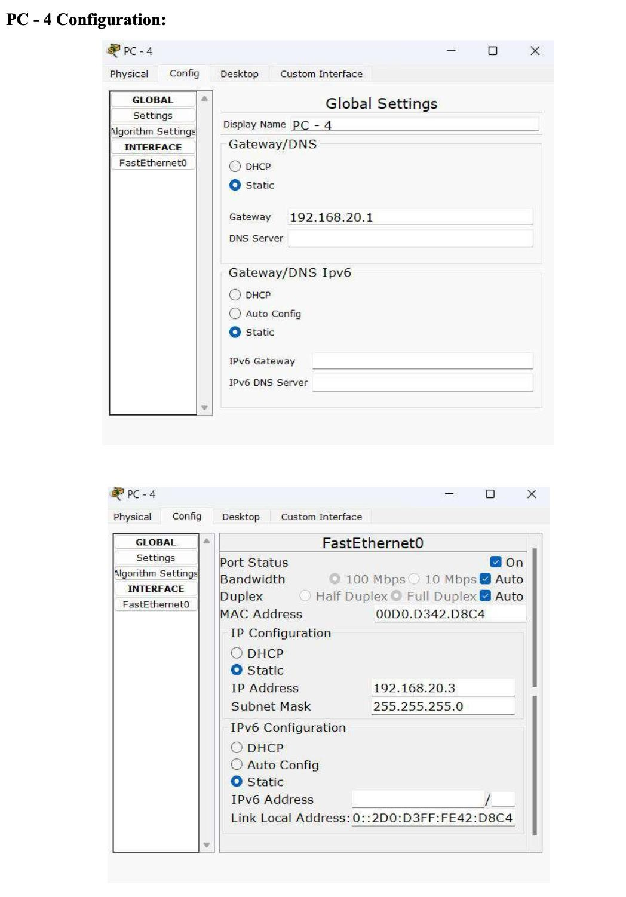

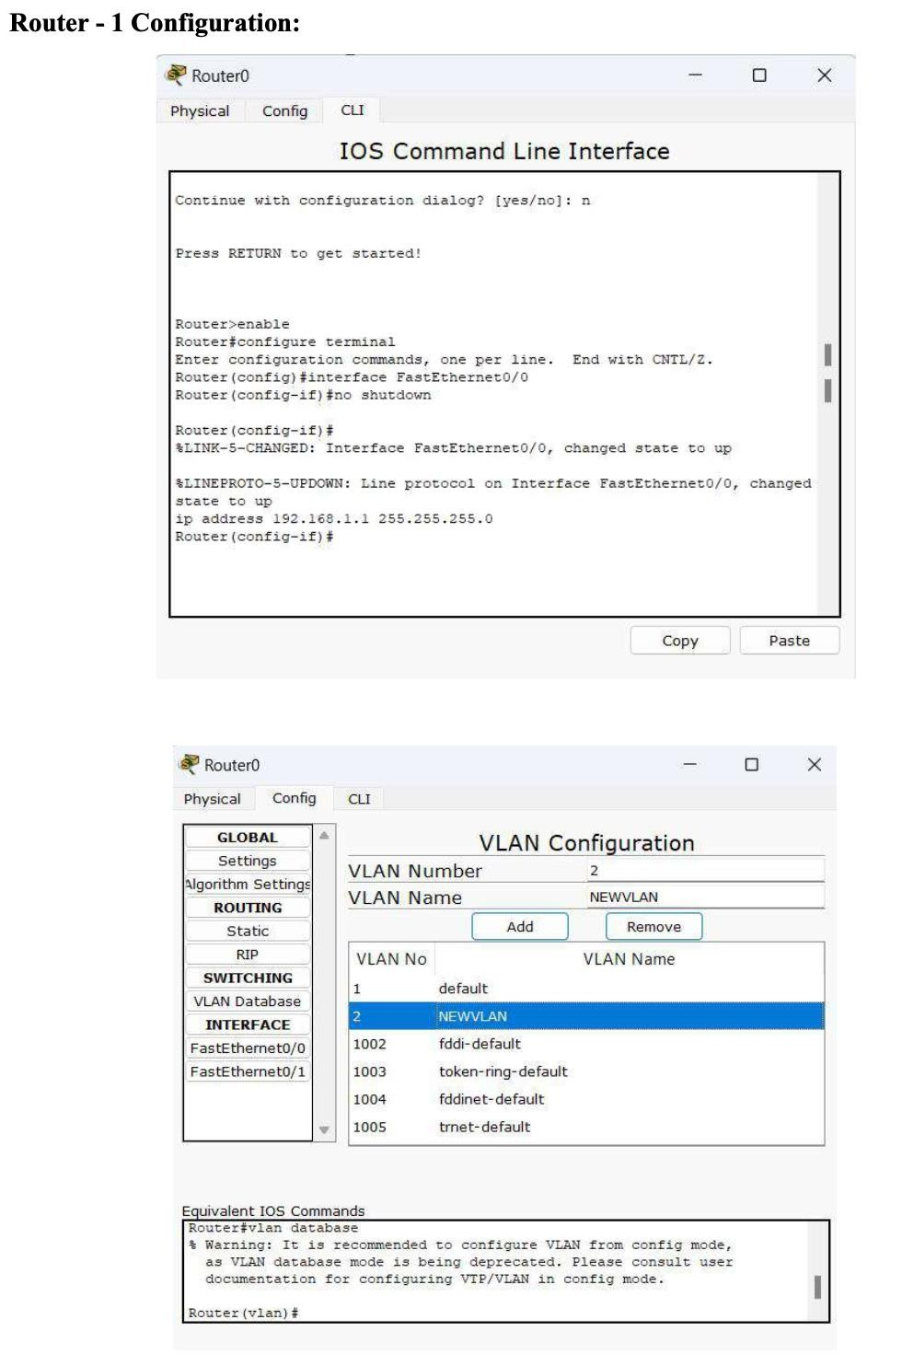

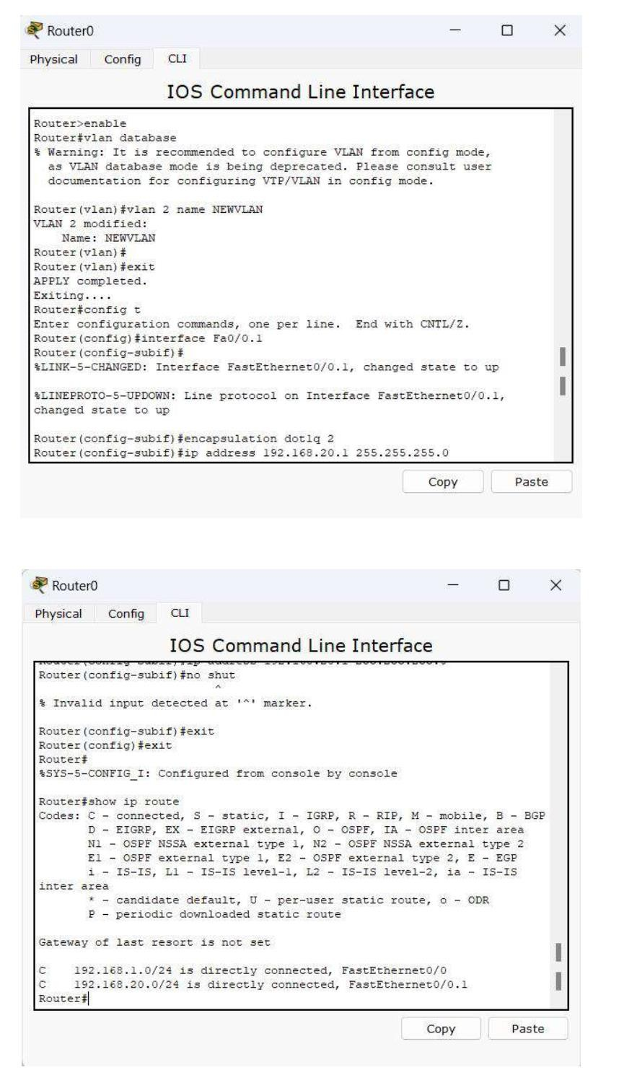

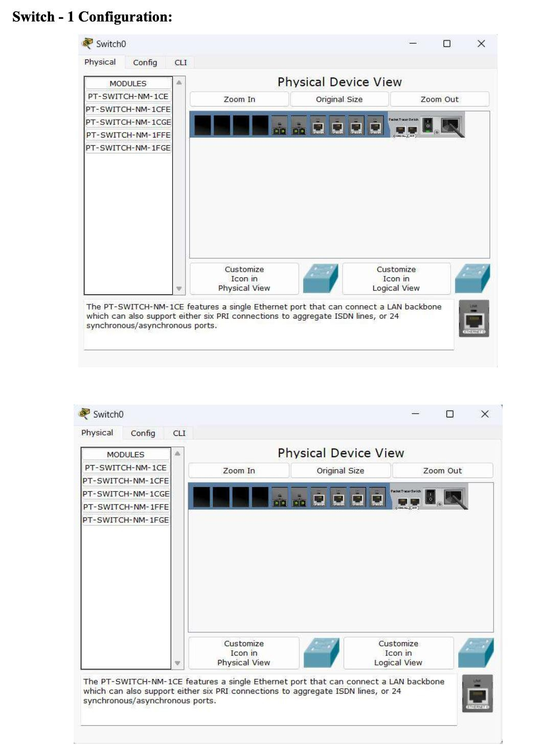

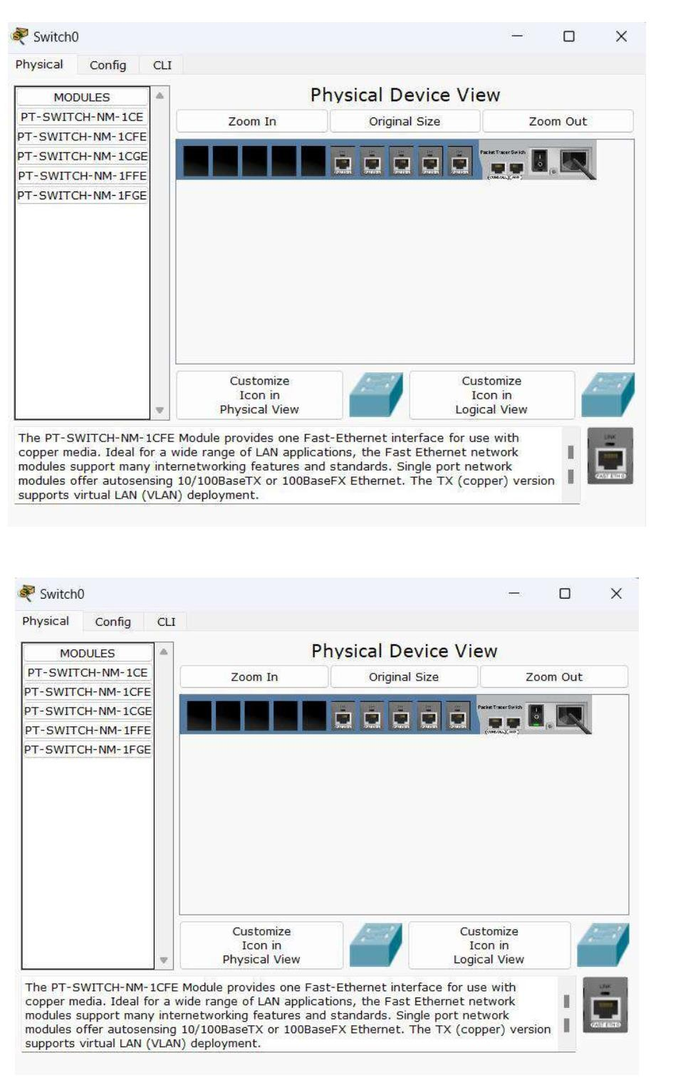

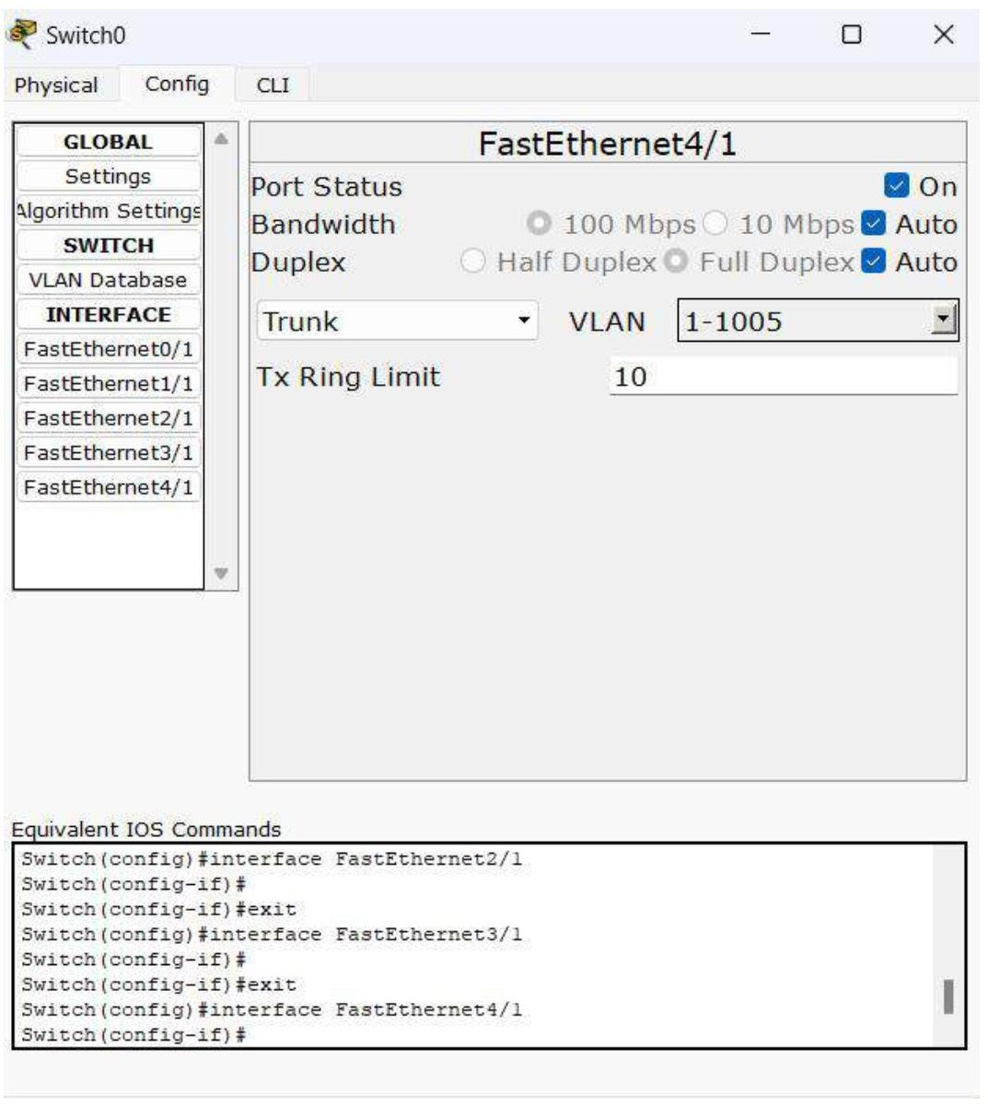

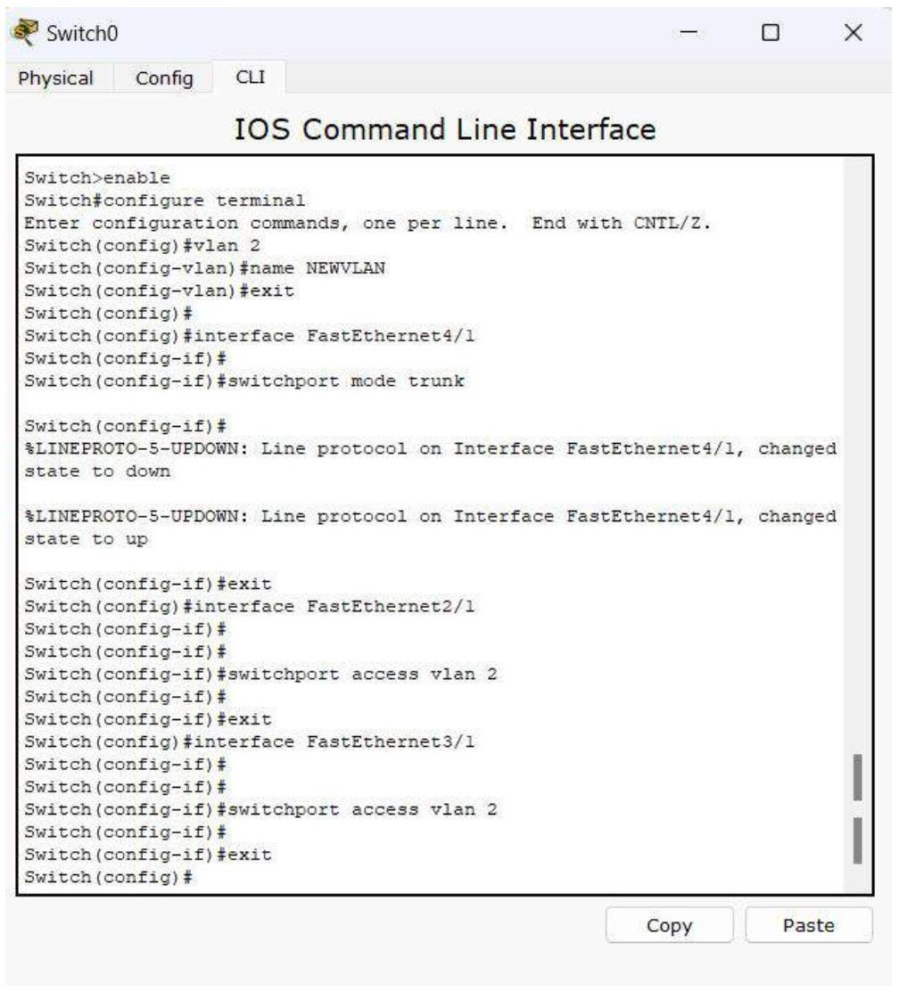

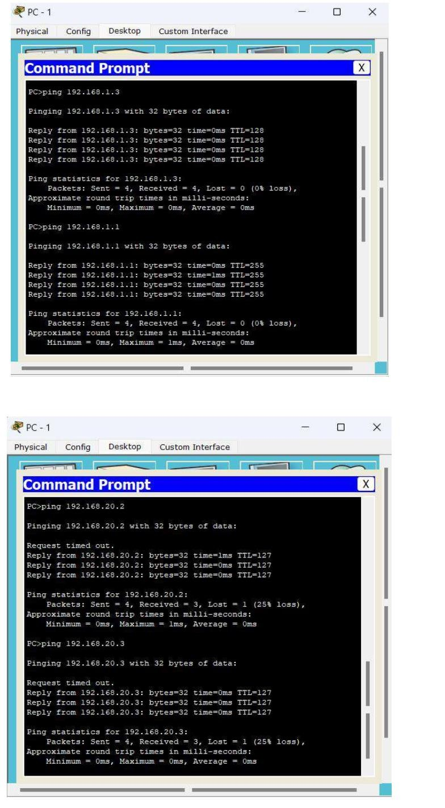

## Lab 12

To construct a WLAN and make the nodes communicate wirelessly.

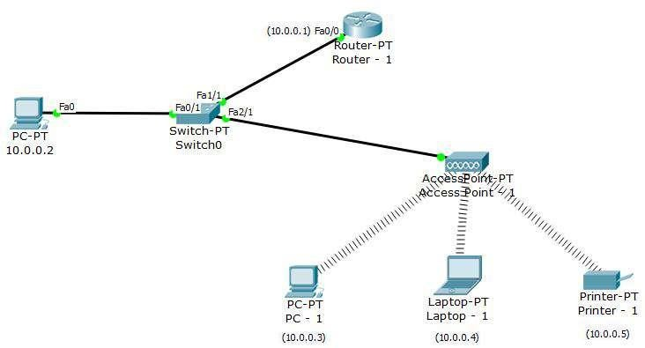

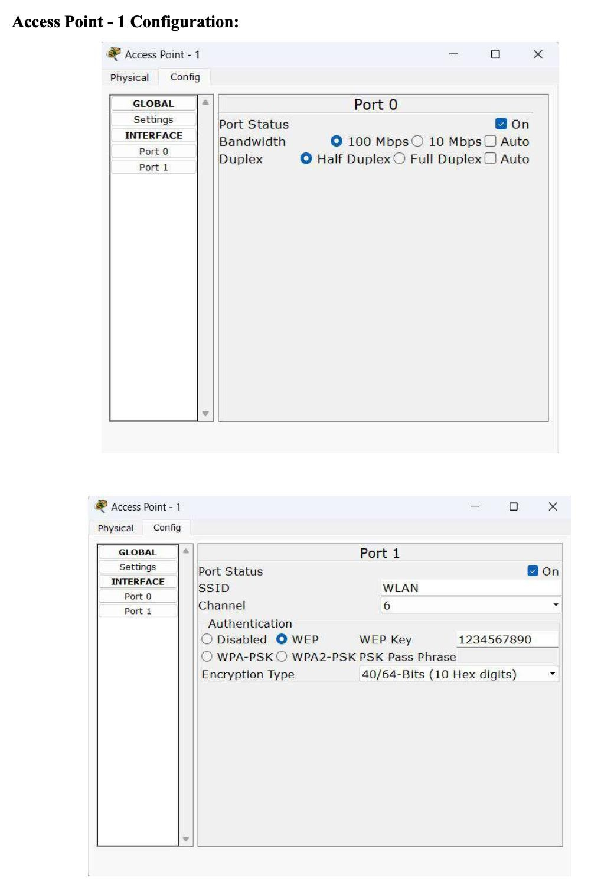

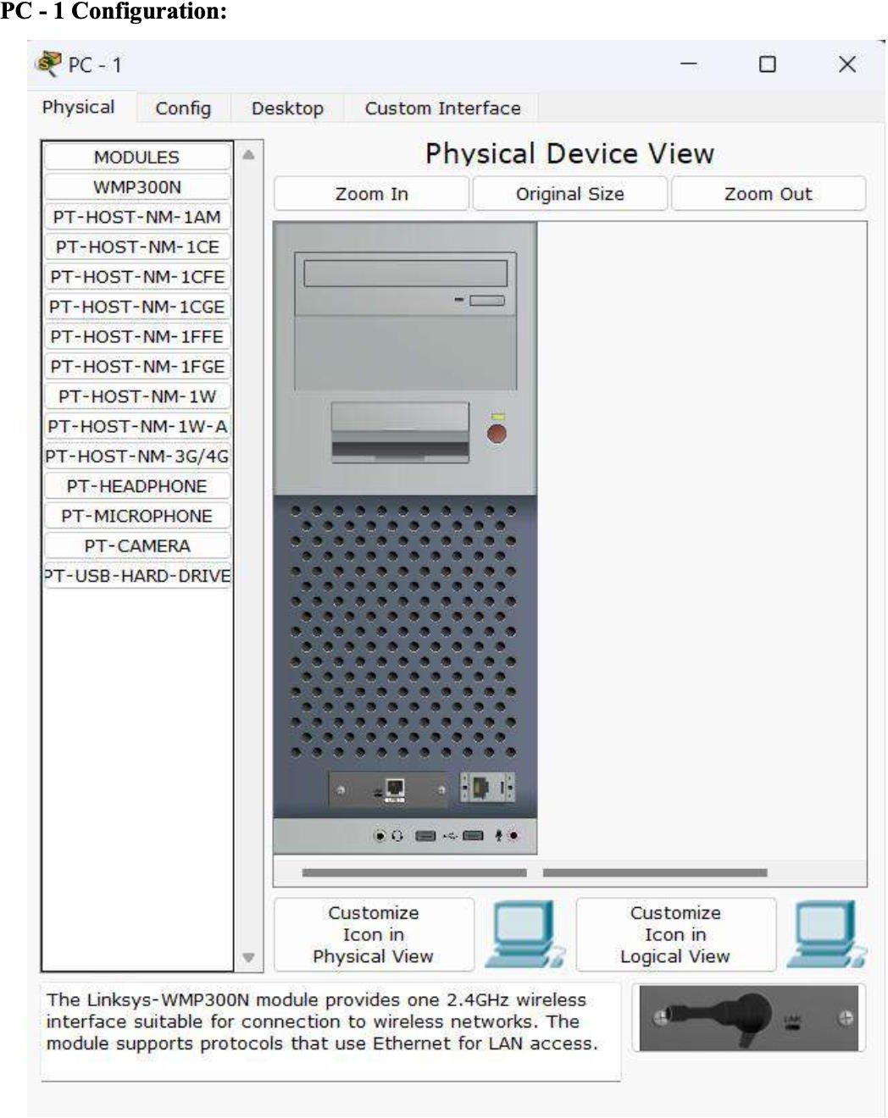

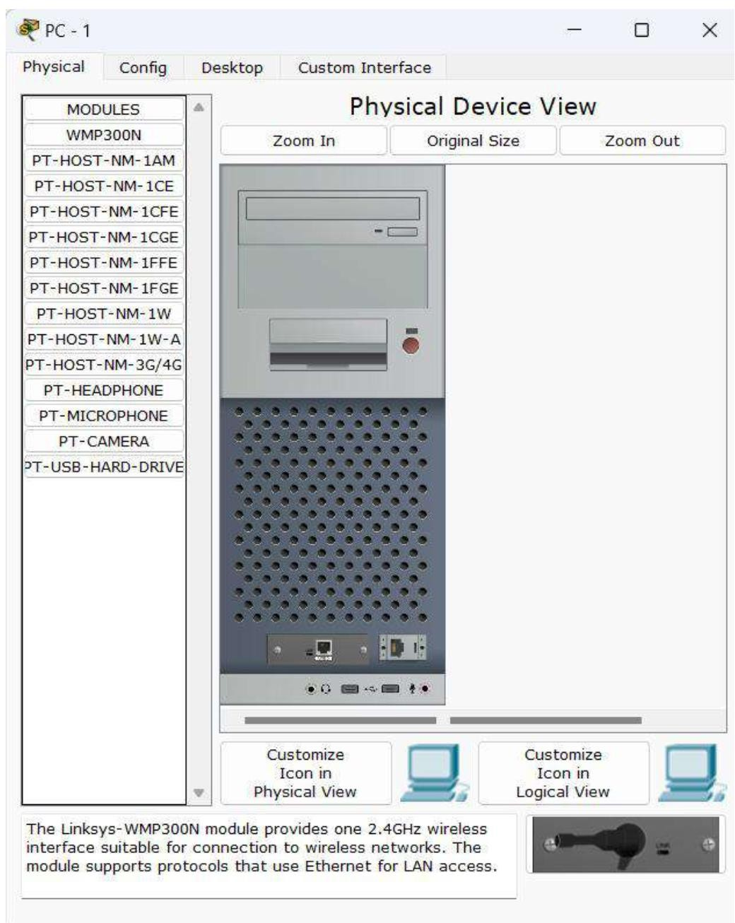

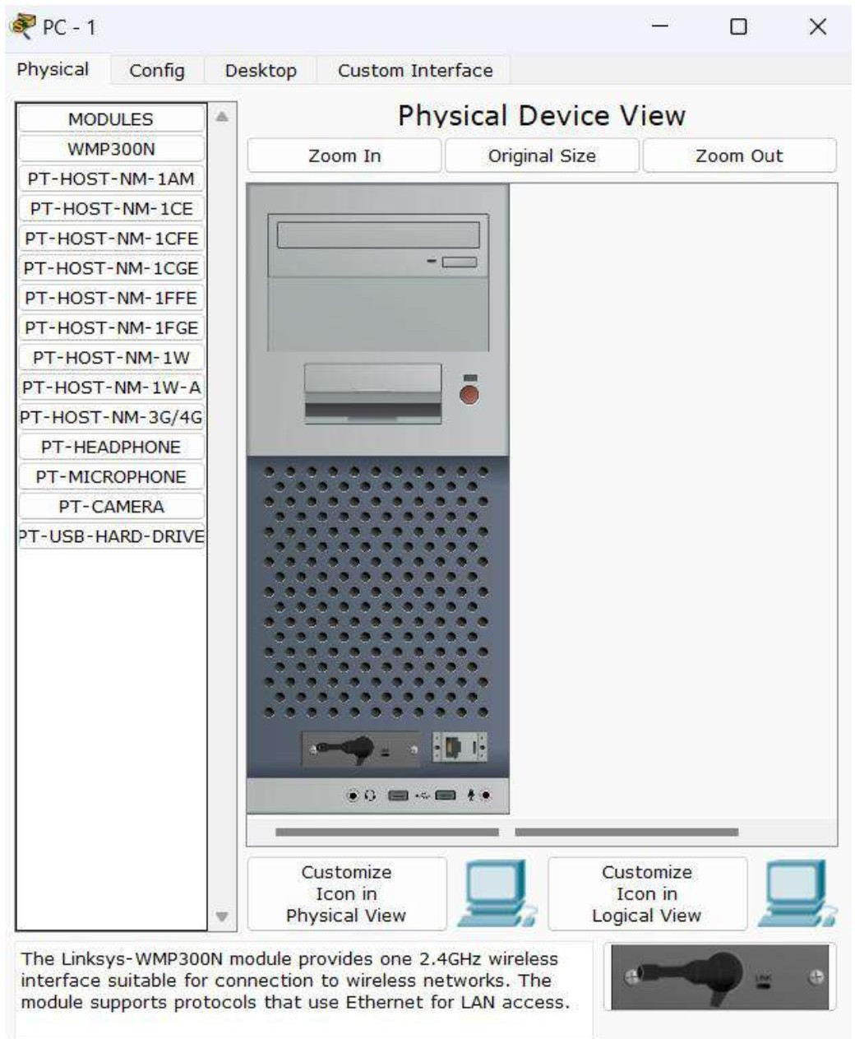

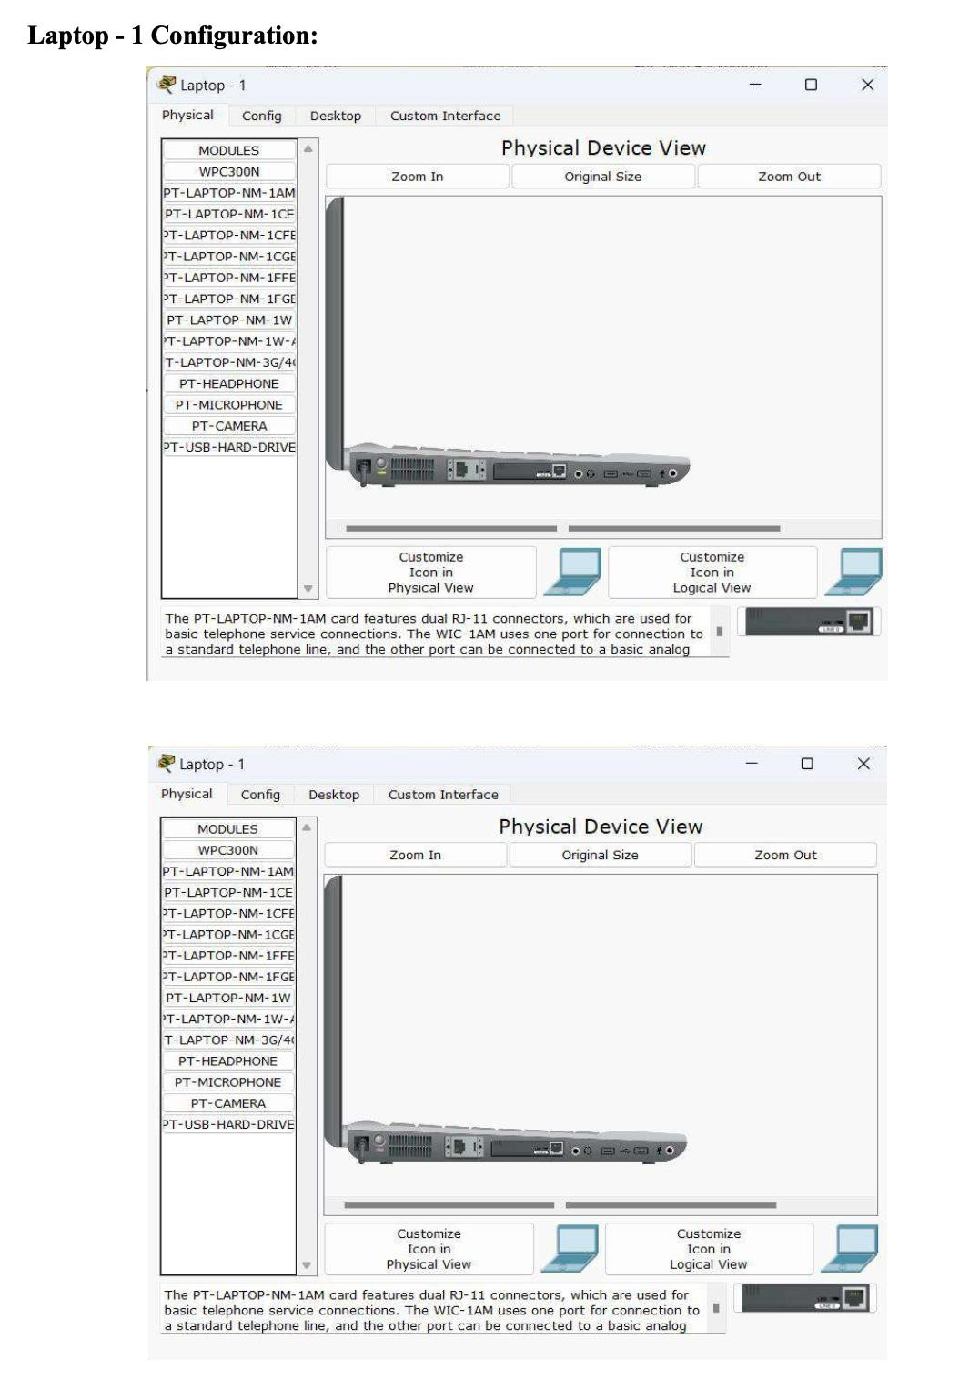

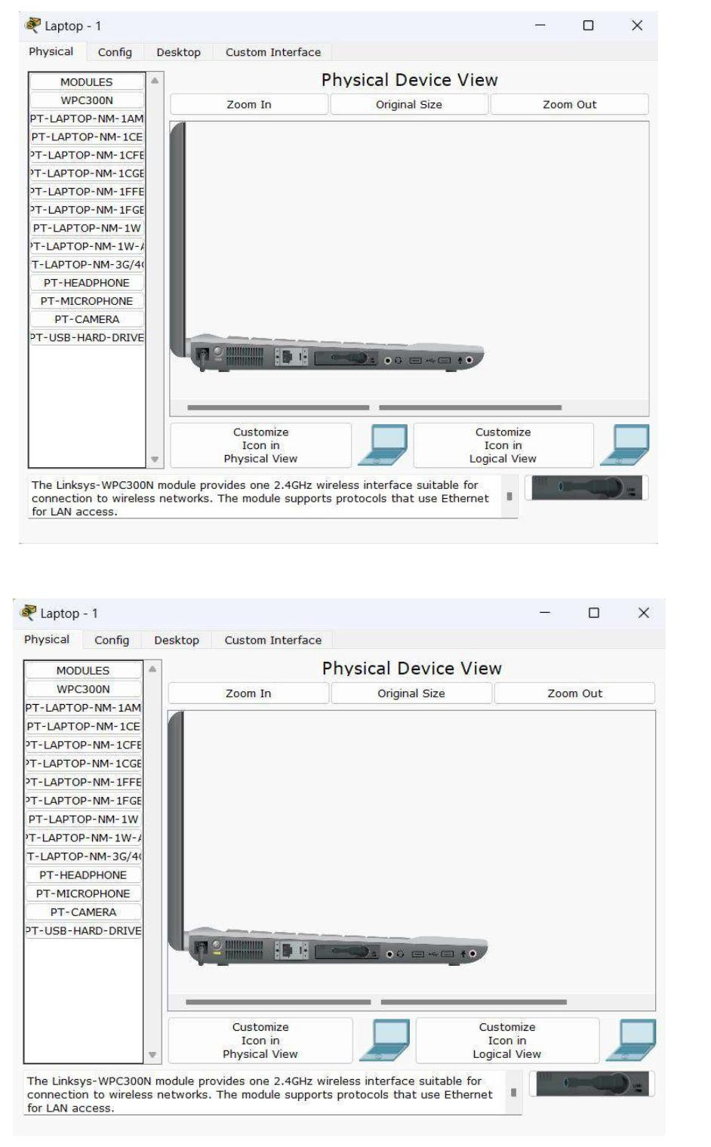

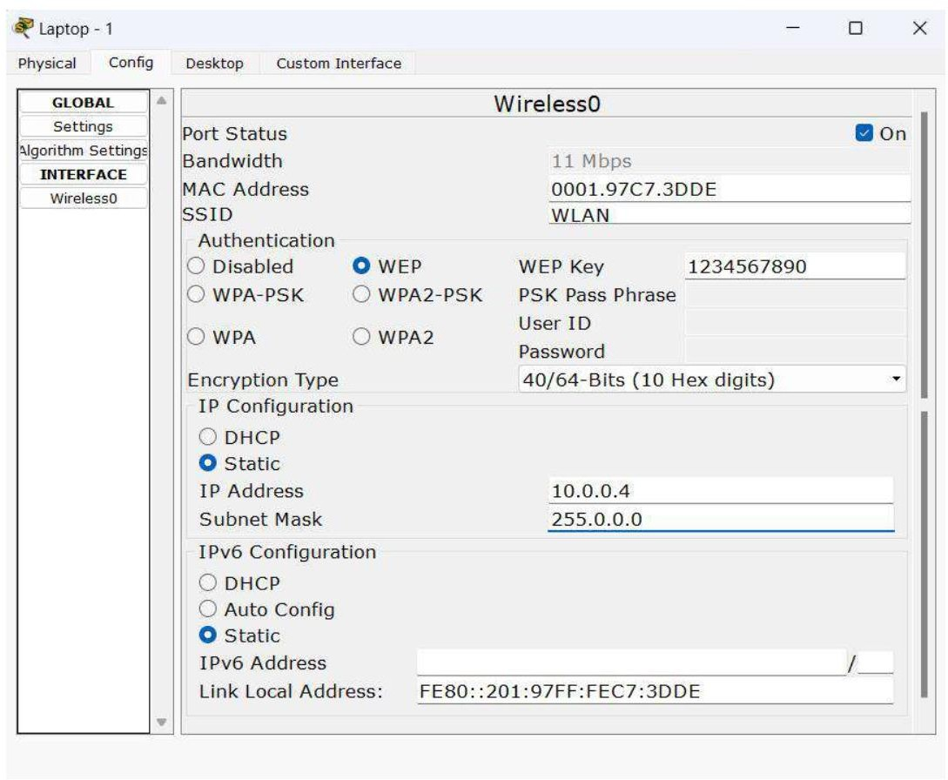

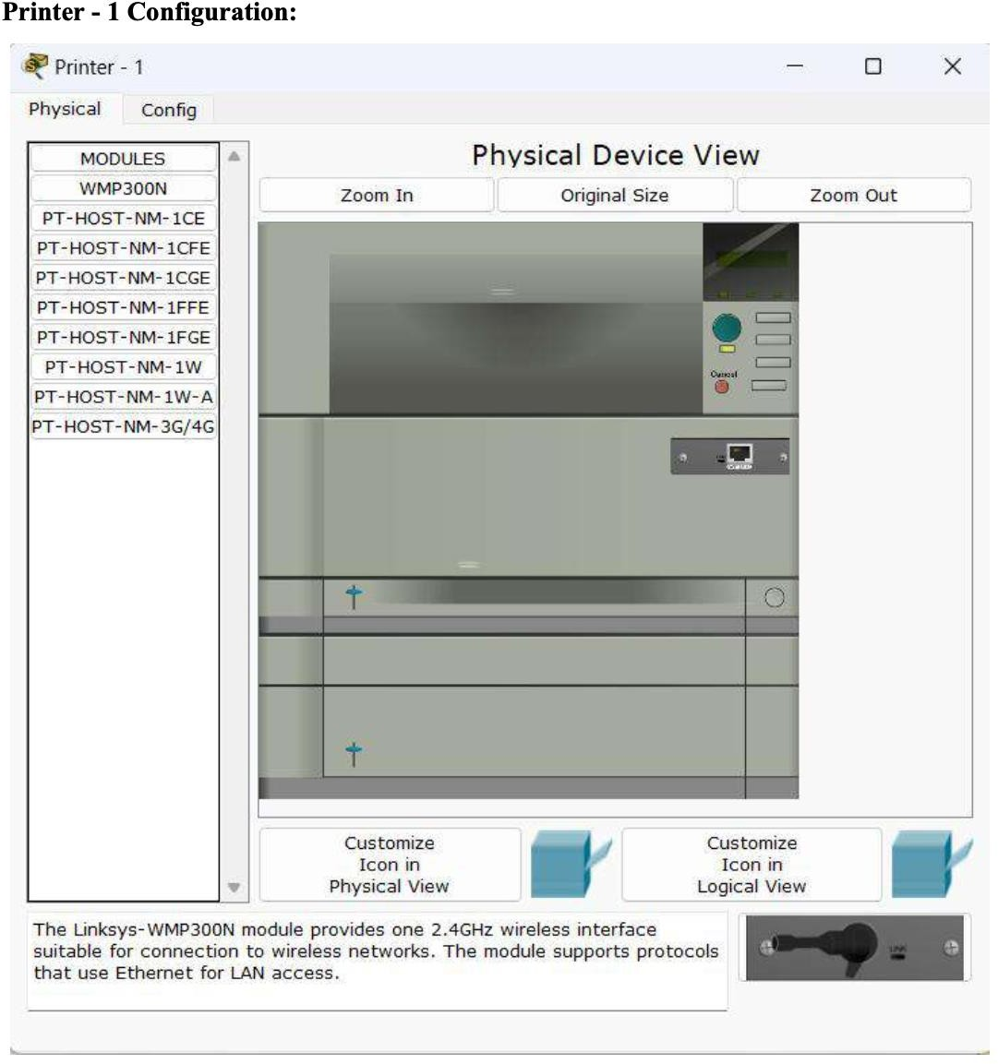

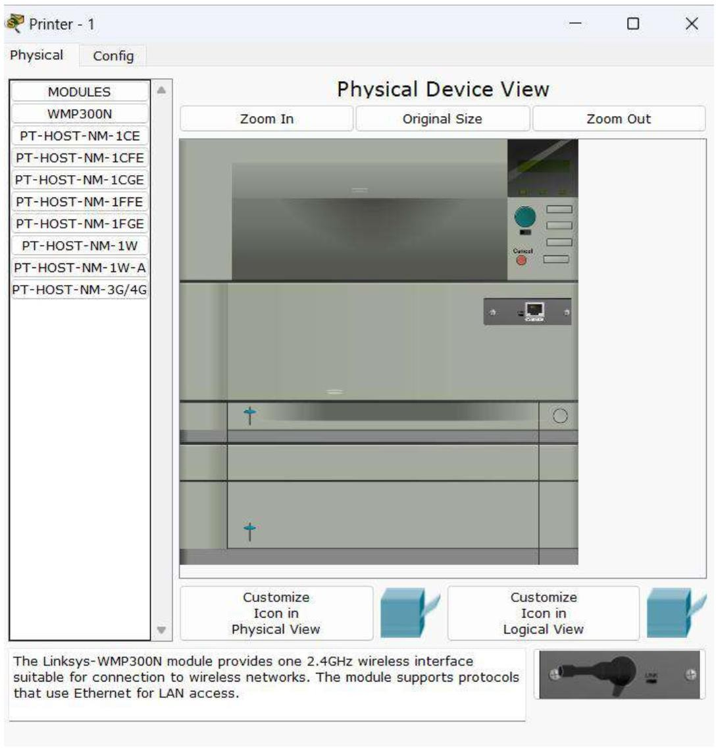

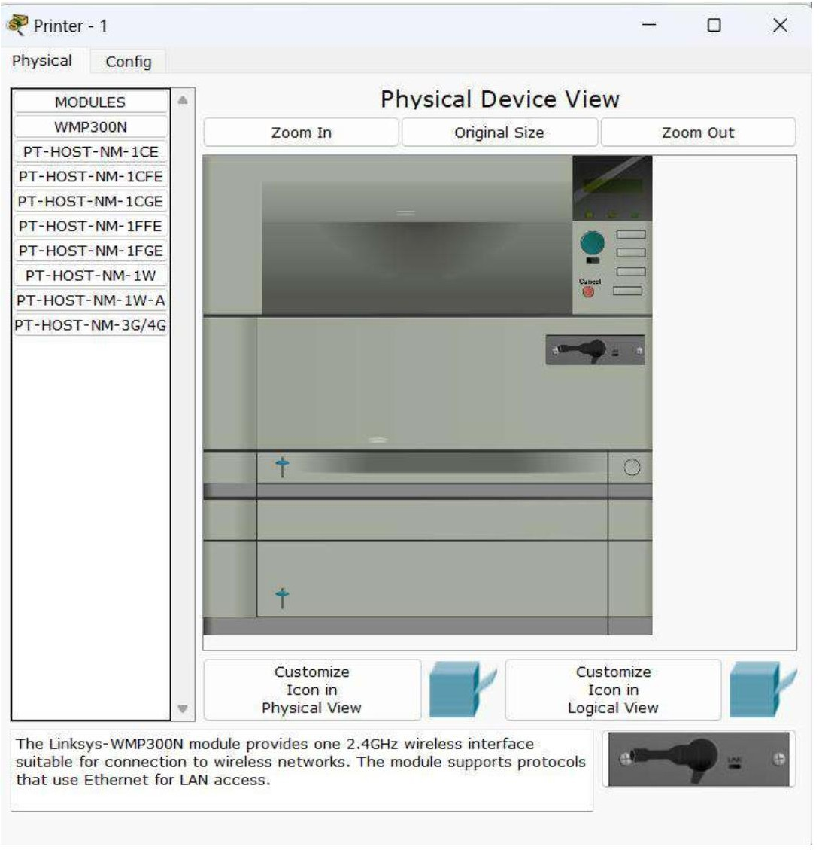

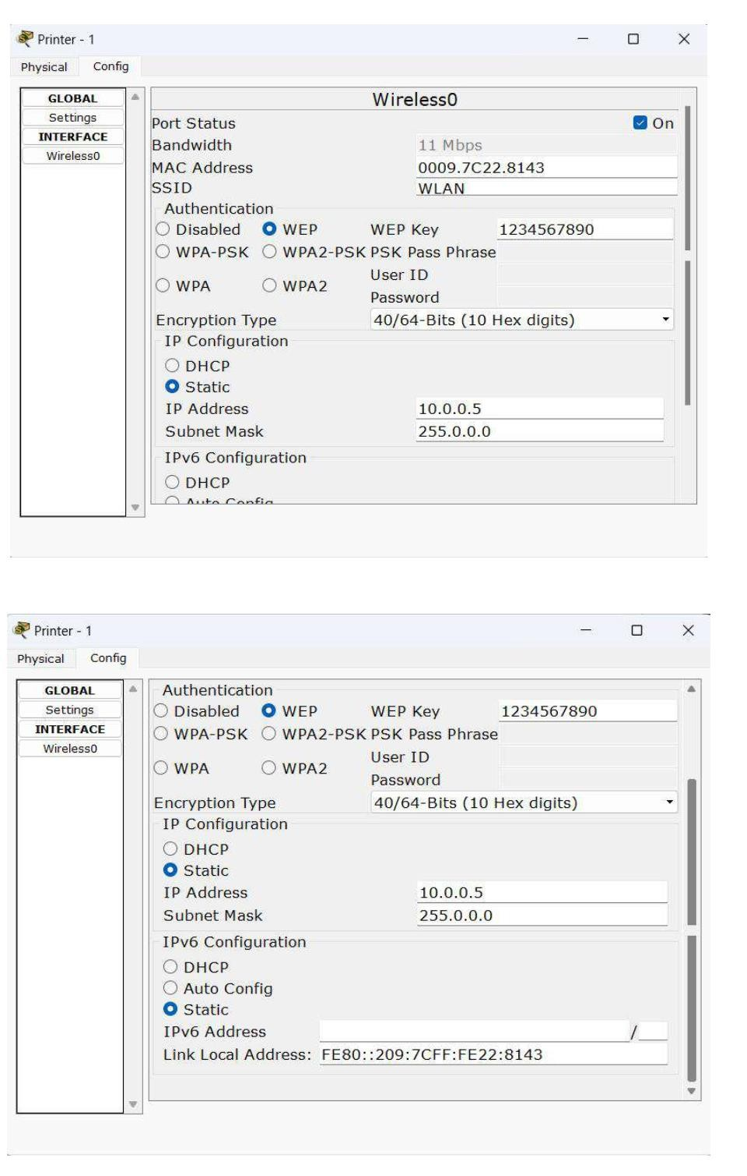

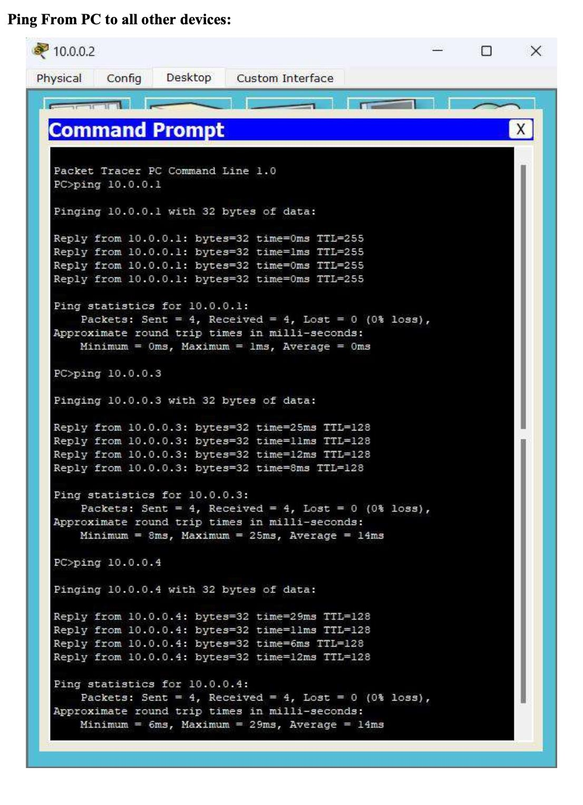

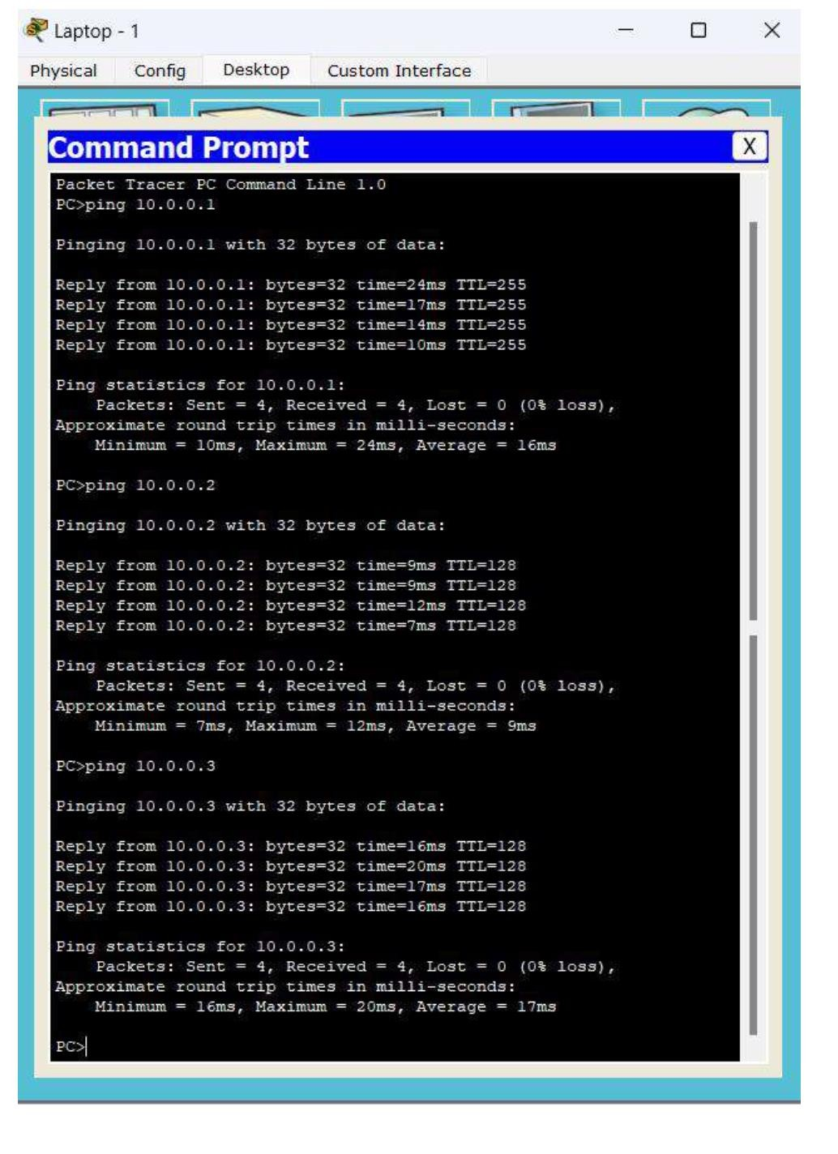

## Lab 13

Write a program for error detecting code using CRC-CCITT (16-bits).

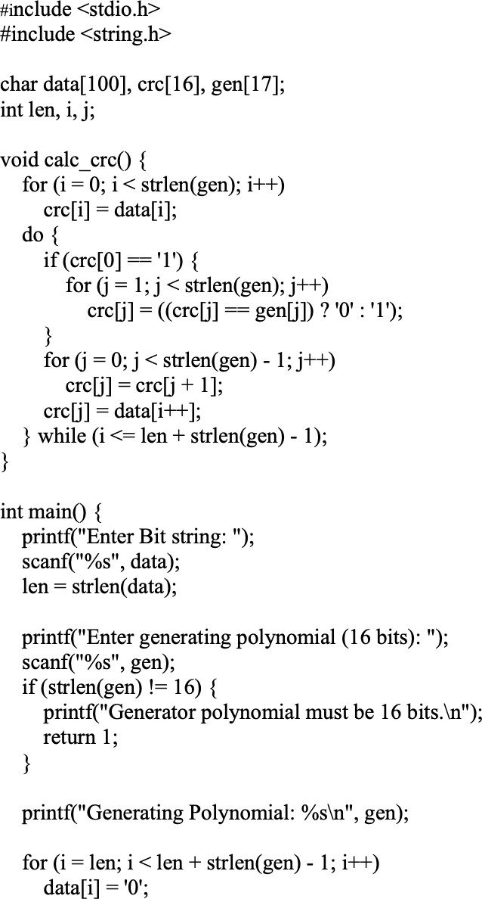

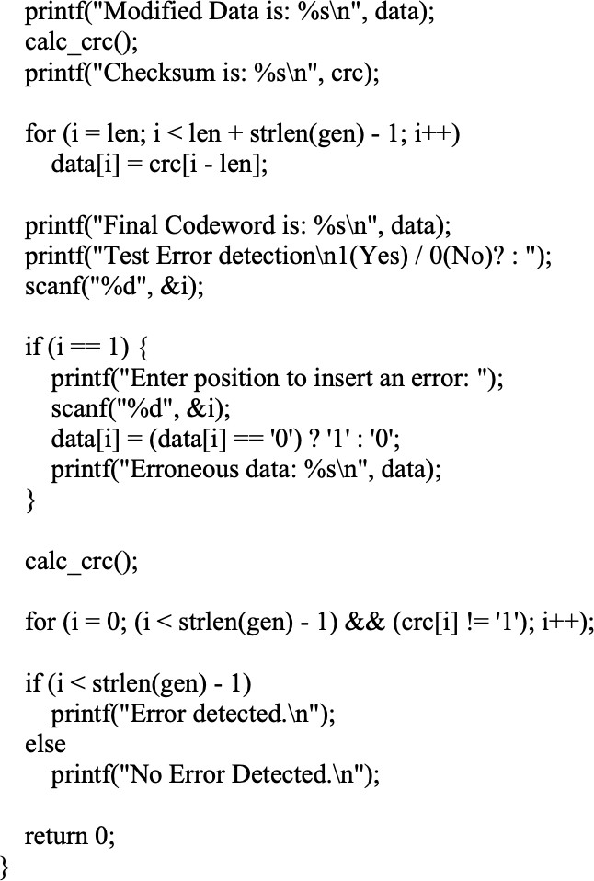

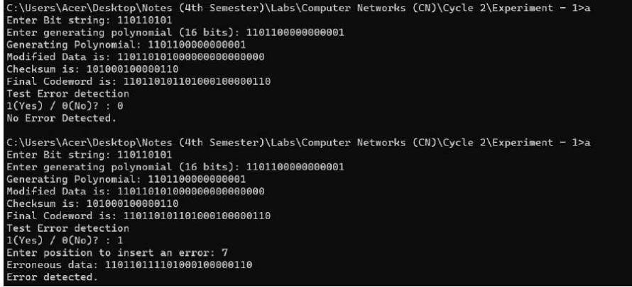

## Lab 14

Write a program for congestion control using Leaky bucket algorithm. Code:

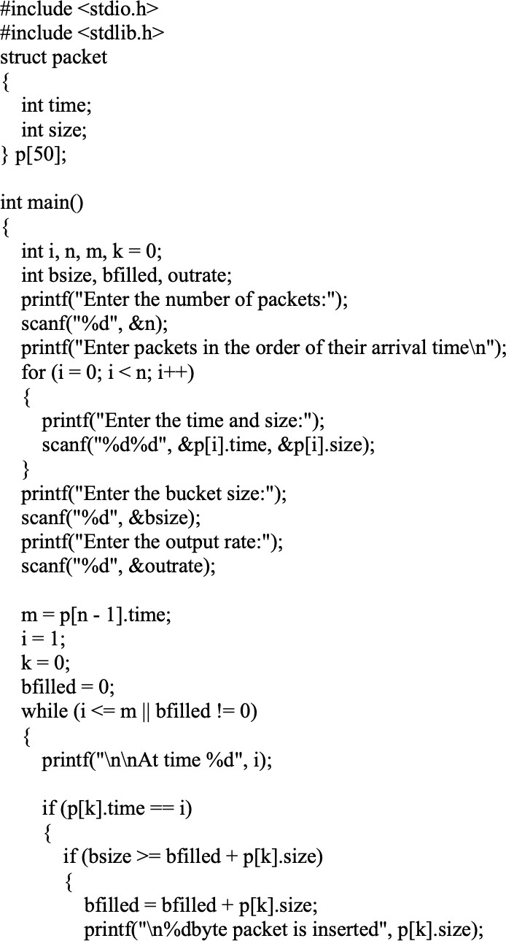

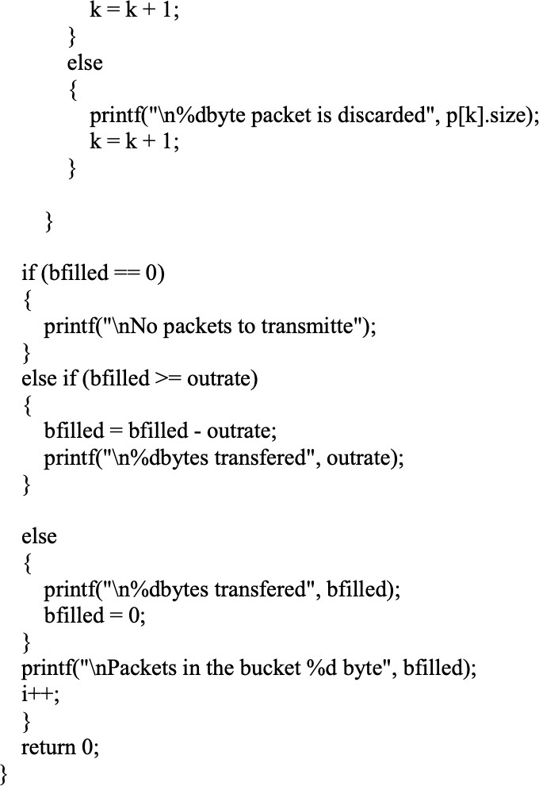

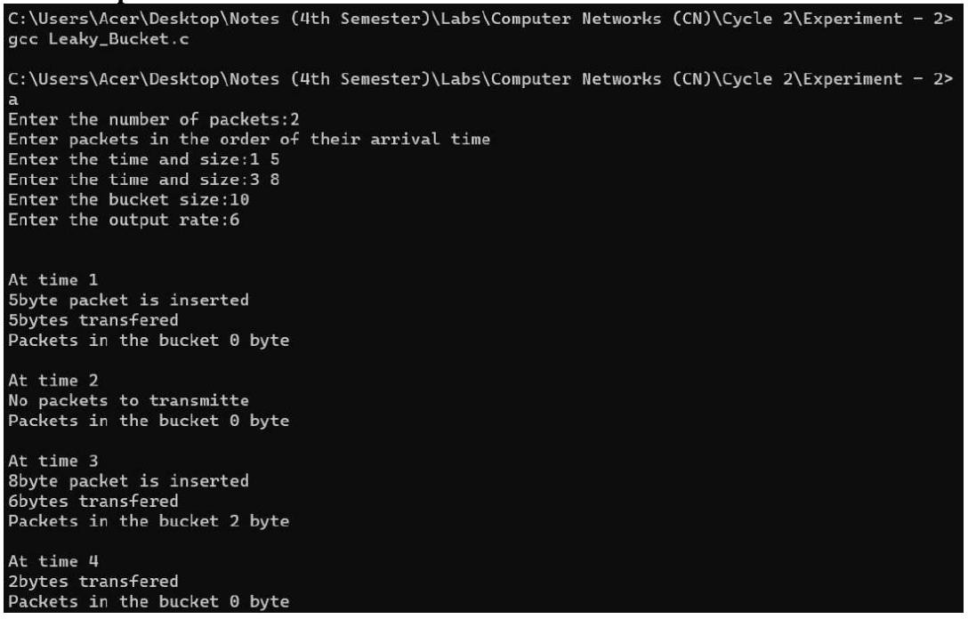

## Lab 15

Using TCP/IP sockets, write a client-server program to make client sending the file name and the server to send back the contents of the requested file if present.

## Code:

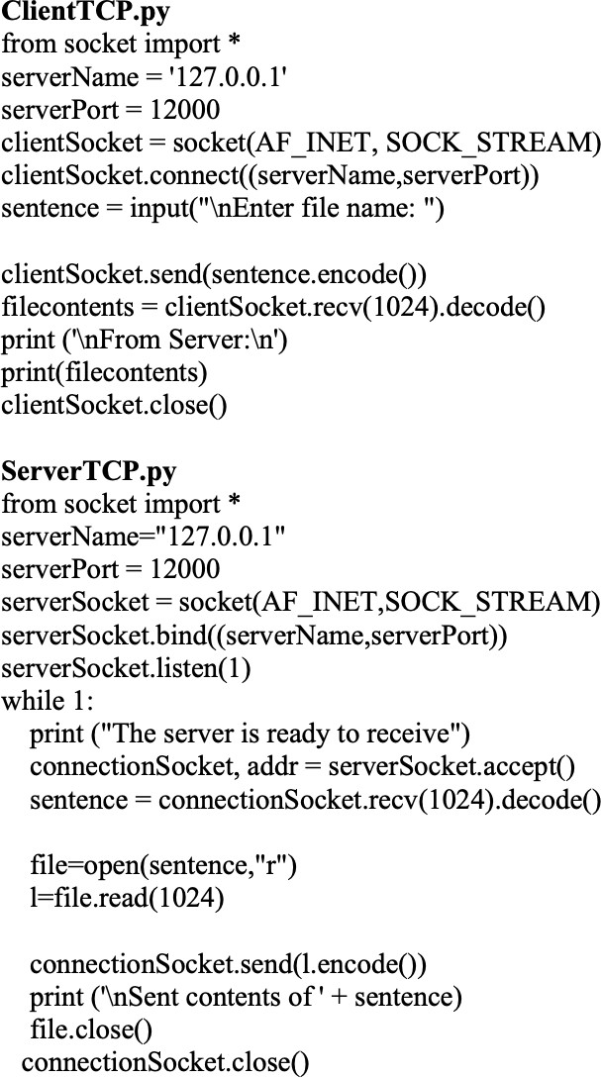

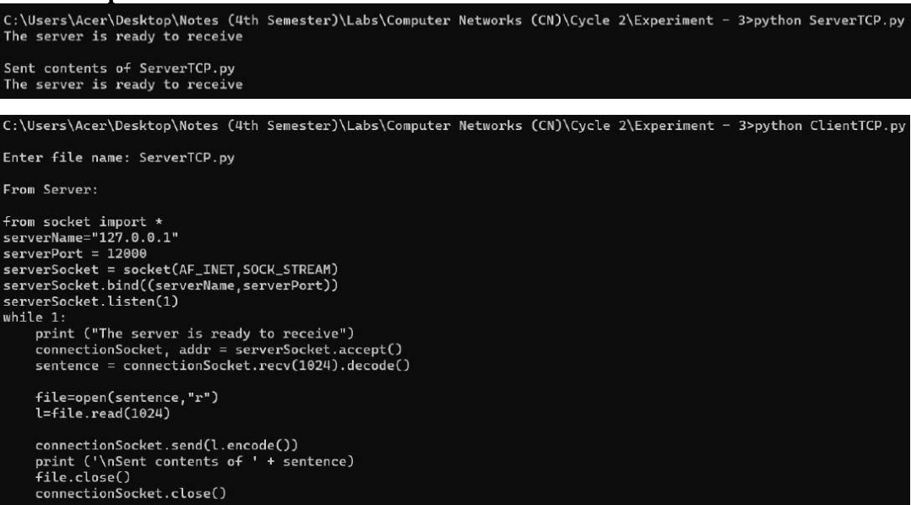

**Lab 16**

Using UDP sockets, write a client-server program to make client sending the file name and the server to send back the contents of the requested file if present.

## Code:

